Bulletin

The Invercargill Parish of the
Methodist Church of New Zealand.
Te Hahi Weteriana o Aotearoa.
Lindisfarne Methodist Church, Worship and Community Centre
Phone 216-0281.
e-mail: office@lindisfarne.org.nz. Website: www.lindisfarne.org.nz
_______________________________

Sunday August 20th 2017

10.00am: Lindisfarne Service with Anne Stoddart.

1.00pm: Tongan Service.

Prayer: Lord, looking back nostalgically can be fun for some, but shocking and hateful for others. Let us be a listening ear and warm shoulder for them in their need.

Lindisfarne Calendar
Sunday 20th August | 10.00am  1.00pm | Lindisfarne Service with Anne Stoddart.  Tongan Service.
Monday 21st | 3.30pm  5.30pm | Story Room.  Girl Guiding New Zealand.
Tuesday 22nd | 9.30am  11.00am  2.00pm  3.30pm | Wild Things  Service at Rowena Jackson Home with Reverend Peter Taylor.  Study Group.  Story Room.
Wednesday 23rd | 7.00pm  7.30pm | North Invercargill Indoor Bowls.  Choir Practice.
Thursday 24th | 10.00am  1.30pm  6.30pm  7.00pm  7.00pm | Craft Circle.  Sit and be Fit.  Cheese Roll Making.  South City Choir Practice.  Blues Bowling Club.
Saturday 26th | 9.00am | Cheese Roll Making.
Sunday 27th August | 10.00am  1.00pm  1.00pm | Lindisfarne Service with Reverend Peter Taylor.  Fijian Service.  Tongan Service.

Brown Bags – Emergency Food Parcels
The green spotted pig is hungry again! Your small coin donation to the pig in the foyer would be greatly appreciated. Or you may prefer to bring a donation of food.- cans of baked beans, spaghetti, soup, fruit, vegetables, fish, packets of pasta, rice, noodles, weetbix, biscuits, soap powder, tea bags are all welcome. We also need jam, soap and toilet paper.
Cheese Rolls

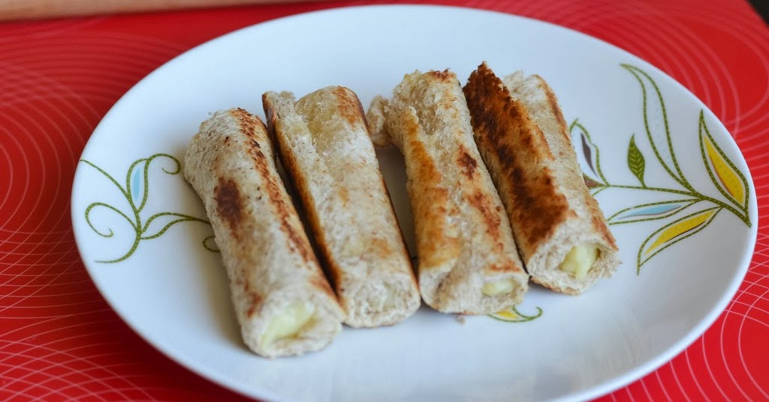

Please come and help to make our cheese rolls on Thursday 24th at 6.30 pm and/or Saturday 26th at 9.00 am.
Bring your own apron. We will supply hats, gloves, knives, bread and cheese mixture!

We have orders for over 7000 cheese rolls i.e. more than 600 trays. (We will make a few extra, in case you forgot to order)

Next Week's Bulletin
Production of the next Bulletin (27th August) will be in the capable hands of Margaret Brass.
Please give any notices to Margaret
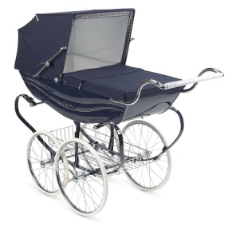

CAN YOU HELP?
We have received a request for an old pram suitable for pamphlet deliveries.
If you can help, please talk to Raewyn Birss.

ROSTER FOR SUNDAY DUTIES
Sunday | August 20th | August 27th |  | September 3rd |  | September 10th
DOOR AND  WELCOME | Noeline and Findlay Collie | Margaret Brass Mags Kelly |  |  | Chris McDonald Tony Weston | Muriel and Cam McCulloch
VAN DRIVER | Bryon King. | Findlay Collie |  |  | Ian Fndlay | Findlay Collie
FLOWERS | Raewyn Birss | Ita Safole | Beverley Robinson |  |  | Dorothy King
MORNING TEA | Neil and Daphne Salter | Keith and Carol McKenzie |  |  | Raewyn Birss Verna Eason | Susanne Staples  Sharon Taylor
NOTICES | Muriel McCulloch | Eddie Bremer |  |  | Judith Stevens | Muriel McCulloch
CRECHE | Susanne Staples | Sharon Taylor |  |  | Amanda Hare | Betty Snell
KIDS KLUB | Annette Little | Annette Little |  |  | TBA | TBA

CENTRE DUTIES
WEEK OF | LAWNS | SECURITY
August 21st- August 27th | Mike Mika | Murray Gibbs
August 28th - September 3rd | Ian Findlay | Joe Wilson
September 4th - September 10th | Runi Safole | Runi Safole
September 11th - September 17th | Neil Salter | Daphne Salter

SOME INVERCARGILL PARISH KEY PERSONNEL
Minister Reverend Peter Taylor 216-0281
Parish Council Secretary Carolyn Weston
Parish Stewards | Eddie Bremer Muriel McCulloch Judith Stevens
Parish Council Chairman Reverend Peter Taylor |  |  |  |  | Treasurer David Little
Parish Council-  Congregational Representatives  Bookings Phone Office 216-0281 |  |  |  | Margaret Brass  Mags Kelly
Prayer Chain Co-ordinators |  |  | Joan and Murray Farley.
Bulletin Editors |  | Peter Lankshear Margaret Brass

