Bulletin

The Invercargill Parish of the
Methodist Church of New Zealand.
Te Hahi Weteriana o Aotearoa.
Lindisfarne Methodist Church, Worship and Community Centre
Phone 216-0281.
e-mail: office@lindisfarne.org.nz. Website: www.lindisfarne.org.nz
_______________________________

Sunday August 27th 2017

10.00am: Lindisfarne Service with Reverend Peter Taylpr

1.00pm: Tongan Service.

1.00pm: Fijian Service
Prayer:
Things can never be the same again, thank God. May we be God’s hands and heart, to make sure our neighbours’ needs are met, physically and spiritually.

Lindisfarne Calendar
Sunday 27th August | 10.00am  1.00pm  1.00pm | Lindisfarne Service with Reverend Peter Taylor.  Fijian Service.  Tongan Service.
Monday 28th | 3.30pm  5.30pm | Story Room.  Girl Guiding New Zealand.
Tuesday 29th | 3.30pm | Story Room.
Wednesday 30th | 7.00pm  7.30pm | North Invercargill Indoor Bowls.  Choir Practice.
Thursday 31st August | 9.00am  10.00am  1.30pm  7.00pm  7.00pm | NZ Family Therapy Specialists  Craft Circle  Sit and Be Fit.  South City Choir Practice.  Blues Bowling Club.
Friday 1st September | 9.00am | NZ Family Therapy Specialists
Saturday 2nd September
Sunday 3rd September | 10.00am  1.00pm | Lindisfarne Communion Service with Reverend Peter Taylor. Parish Lunch to follow.  Tongan Service.

Brown Bags – Emergency Food Parcels
The green spotted pig is hungry again! Your small coin donation to the pig in the foyer would be greatly appreciated. Or you may prefer to bring a donation of food.- cans of baked beans, spaghetti, soup, fruit, jam, vegetables, fish, packets of pasta, rice, noodles, weetbix, biscuits, soap powder, tea bags, soap, toilet paper.
Cheese Rolls

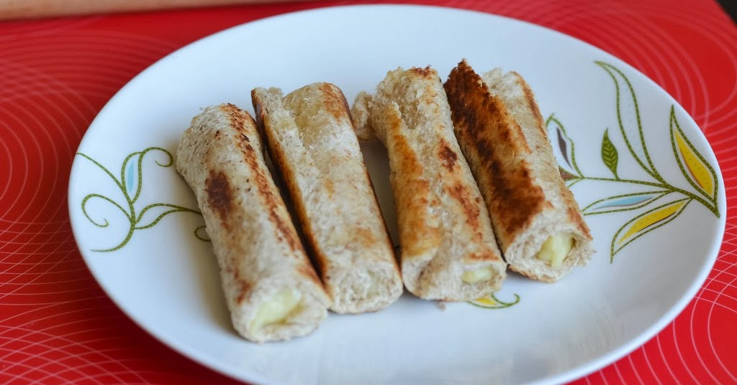

Thank you to everyone who helped to sell and make cheese rolls. Rolls ordered can be collected in the foyer after today’s service. There will also be extras for sale - $6.50 for one dozen, $13 for two, $19.50 for three or $25 for four. Credit is available (interest free)!

Events Coming Up

Saturday 9 September – Talents and Treasures
Our version of an Antiques Roadshow. There will be displays of lace-making, flowers, patchwork, art, cameras, fine china etc.
You can still help by bringing anything suitable for a White Elephant table e.g. small ornaments, embroidered cloths and doilies, pretty china, lace work, other delicate handwork.
Ask Betty if you need guidance.

Wednesday 20 September – Mid-week Communion service at 11.30 am. (Pastoral Care team please note the change of date.)

Saturday 4 November - Garage Sale
Start sorting out goods for sale now. They can be stored from now on to be ready for the big sale day. Talk to Daphne to arrange this.

ROSTER FOR SUNDAY DUTIES
Sunday | August  27th |  | September 3rd | September 10th |  | September  17th
DOOR AND  WELCOME | Margaret Brass Mags Kelly |  | Chris McDonald Tony Weston | Muriel and Cam McCulloch |  | Evelyn and Neil Cruickshank
VAN DRIVER | Findlay Collie |  | Ian Fndlay | Findlay Collie |  | Daphne Salter
FLOWERS | Ita Safole | Beverley Robinson |  |  | Dorothy King | Mags Kelly
MORNING TEA | Noeline and Fin Collie |  | Carol and Keith McKenzie | Susanne Staples  Sharon Taylor |  | Mags Kelly  Betty Snell
NOTICES | Eddie Bremer |  | Judith Stevens | Muriel McCulloch |  | Eddie Bremer
CRECHE | Sharon Taylor |  | Amanda Hare | Betty Snell |  | Susanne Staples
KIDS KLUB | Annette Little |  | Carol McKenzie | Carol McKenzie |  | TBA

DUTIES NEXT SUNDAY
COMMUNION | Stephanie Fannin and Carolyn McDonald
PARISH LUNCH | Beth and Murray Gibbs

CENTRE DUTIES
WEEK OF | LAWNS | SECURITY
August 28th - September 3rd | Ian Findlay | Joe Wilson
September 4th - September 10th | Runi Safole | Runi Safole
September 11th - September 17th | Neil Salter | Daphne Salter
September 18th - September 24th | Lester Dean | Cam McCulloch

SOME INVERCARGILL PARISH KEY PERSONNEL
Minister Reverend Peter Taylor 216-0281
Parish Council Secretary Carolyn Weston
Parish Stewards | Eddie Bremer Muriel McCulloch Judith Stevens
Parish Council Chairman Reverend Peter Taylor |  |  |  | Treasurer David Little
Parish Council-  Congregational Representatives  Bookings Phone Office 216-0281 |  |  | Margaret Brass  Mags Kelly
Prayer Chain Co-ordinators |  | Joan and Murray Farley.
Bulletin Editors |  | Peter Lankshear Margaret Brass

