Lindisfarne Bulletin
The Invercargill Parish of the
Methodist Church of New Zealand.
Te Hahi Weteriana o Aotearoa.

Lindisfarne Methodist Church, Worship and Community Centre.
Phone 216-0281.
e-mail: office@lindisfarne.org.nz. Website: www.lindisfarne.org.nz

Sunday August 9th 2015

10.00am: Lindisfarne Service with Anne Stoddart.

10.00am: Bluff Communion Service with Reverend Peter Taylor

1.00pm: Tongan Service.

1.00pm:Fijian Service.

2.00pm: Peacehaven Service with Peter Taylor.
Prayer. Lord, we want to be contented people. We do not want to be like the Israelites, grumbling in the desert. Help us to steadfastly look to you, to remember your blessings, to rely on your strength, and to recount to others how good you are, and how truly blessed we are. You are our strength and song.
Thank you Lord.

Lindisfarne Calendar
Sunday 9th August | 10.00am  10.00am  1.00pm  1.00pm  2.00pm | Lindisfarne Service with Anne Stoddart.  Bluff Communion Service with Reverend Peter Taylor.  Tongan Service.  Fijian Service.  Peacehaven Service with Reverend Peter Taylor.
Monday 10th | 3.30pm  7.30pm | Story Room.  North Inner Wheel.
Tuesday 11th | 9.00am  3.30pm | Fostering Kids.  Story Room.
Wednesday 12th | 7.00pm  7.30pm | Invercargill Indoor Bowling Club.  Choir Practice.
Thursday 13th | 10.00am  11.00am  1.30pm  7.00pm | Craft Circle  Cargill Home Service with Reverend Peter Taylor.  Sit and Be Fit.  Blues Bowling Club.
Friday 14th | ------------ | Set up for Southland Competitions
Saturday 15th | 9.00am | Southland Competitions.
Sunday 16th August | 10.00am  10.00am  1.00pm | Lindisfarne Service with Neil Salter  Riverton AGM Service with Reverend Peter Taylor.  Southland Competitions.

Flower Roster We have a gap in our flower roster .Are you the person to fill it - about six times a year? See Margaret if you can help.

Coming Up
Sunday 13th September – Soup and Bread Roll lunch.
Keep this date free. More information next week.

First Aid

The Parish Council hopes to have a defibrillator installed in our Centre (for use in case of a heart attack). The defibrillator gives you instructions as you use it, so it can be operated by anyone.
But if you would like full training, please tell Raewyn Birss. She would also like to know of people who have a current First Aid certificate, so are already familiar with the operation of a defibrillator.

Cheese Rolls
Thanks to everyone who helped with the cheese roll fundraiser, getting orders, making the rolls, delivering them - and eating them!

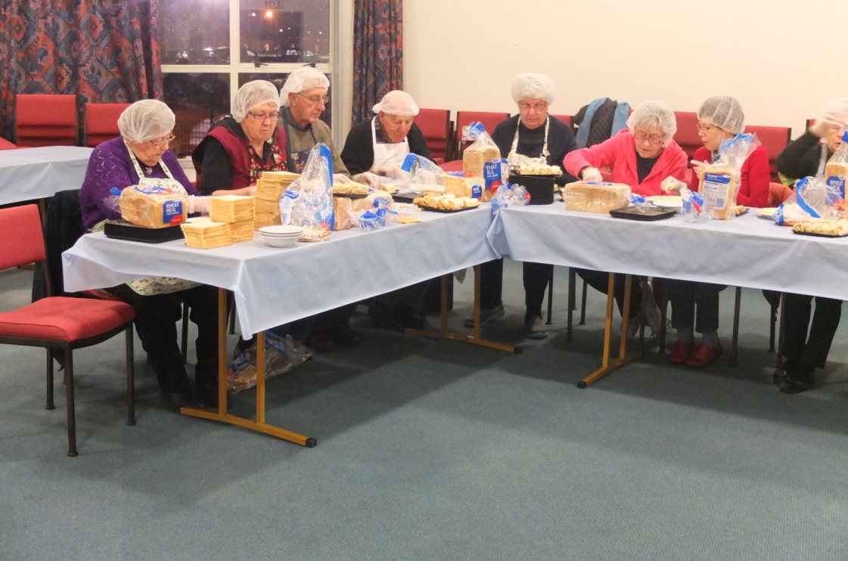

Not a re-enactment of da Vinci's Last Supper. It's the Lindisfarne cheese roll assembly line in action.

ROSTER FOR SUNDAY DUTIES
SUNDAY | August 9th | August 16th |  | August 23rd | August 30th
DOOR AND  WELCOME | Beth and Murray Gibbs | Ita and Runi Safole |  | Tony Weston  Nicol Macfarlane | Glenys and Ian Findlay
VAN DRIVER | Eddie Bremer | Ron Taylor |  | Bryon King | Murray Gibbs
FLOWERS | Beatrice Croft | Ita Safole |  | Nicol Macfarlane | Betty Snell
MORNING TEA | Sharon Taylor Carolyn Clearwater |  | Judith Stevens Fay Brown | Glenys and Ian Findlay | Beth Gibbs  Betty Snell
NOTICES | Betty Snell | Carol McKenzie |  | Eddie Bremer | Betty Snell
CRECHE | Carol McKenzie | Betty Snell |  | Susanne Staples | Sharon Taylor
KIDS KLUB | Lynley Dean | Noeline Collie |  | Noeline Collie | Noeline Collie

CENTRE DUTIES
WEEK OF | LAWNS | SECURITY
August 10th - August 16th | Ron Taylor | Ron Taylor
August 17th -August 23rd | Bryon King | Bryon King
August 24th - August 30th | Murray Gibbs | Murray Gibbs
August 31st - September 6th | Chris McDonald | Margaret Brass

SOME INVERCARGILL PARISH KEY PERSONNEL
Minister Reverend Peter Taylor 216-0281
Parish Secretary Verna Eason
Parish Stewards | Carol McKenzie Betty Snell Eddie Bremer
Parish Council Chairman Reverend Peter Taylor |  |  |  |  | Treasurer David Little
Parish Council-  Congregational Representatives |  |  |  | Margaret Brass  Nicol Macfarlane  Mags Kelly
Prayer Chain Co-ordinators |  |  | Joan and Murray Farley.
Bulletin Editors |  | Peter Lankshear Margaret Brass

Affordables Shop Manager Carolyn 216-9676

