Bulletin
The Invercargill Parish of the Methodist Church of New Zealand.
Te Hahi Weteriana o Aotearoa.

Lindisfarne Methodist Church, Worship and Community Centre.
Phone 216-0281.
e-mail: office@lindisfarne.org.nz Website: www.lindisfarne.org.nz


Lindisfarne Methodist Church

_______________________________________________________________

Sunday December 13th 2020.
Third Sunday in Advent.

10.00am: Lindisfarne Service led by the Reverend Peter Taylor and featuring the Choir and Kids Klub.

1.00pm: Tongan Service.

1.00pm: Fijian Service.

2.00pm: Peacehaven Service led by the Reverend Peter Taylor.
Prayer:
Thank you, Lord, for your love and compassion.
We often stray from you in our thoughts and deeds.
Let today be the time when we come closer to you and renew our praise as we worship you with love and adoration.

Calendar
Sunday 13th  December | 10.00am  1.00pm  1.00pm  2.00pm  7.00pm | Lindisfarne Service with the choir.  Tongan Service.  Fijian Service.  Peacehaven Service with the Reverend Peter Taylor.  Private Booking.
Tuesday 15th | 2.00pm | Advent Study Group.
Wednesday 16th | 5.00pm  6.00pm | Private Booking.  Carol Singing. (See notice below.)
Thursday 17th | 6.30pm | Setup for Friday’s Sri Lankan event.
Friday 18th | 6.00pm | Sri Lankan Society.
Saturday 19th | 4.00pm | Private Booking.
Sunday 20th | 10.00am  1.00pm  5.00pm | Lindisfarne Service with Nicol Macfarlane.  Tongan Service.  Invercargill Malayalies Group

Carol Singing
The church choir will be carol singing around town this coming Wednesday.

We will be starting at 6.00pm at Rowena Jackson village, either at Anne Stoddart’s (T/H 71) or Barbara Richardson’s (T/H 66).

All are welcome to join us.

Office Holiday Closing

The Lindisfarne Office will close for the Christmas Holidays on Friday 18th December and reopen on Monday 18th January.

Pop Up Carols
A Christmas Sing Along

The Ascot Park Brass Band, the Ensemble, and Friends are planning a sing along tomorrow evening, Monday 14th December from 7.00pm to 8.15pm.

In the Gala Street Reserve (in front of the Cricket Ground).

Come and join in this free event and sing along with the band and choir to your favourite traditional carols and Christmas songs.

If postponed the sing-along will be on Tuesday 15th.

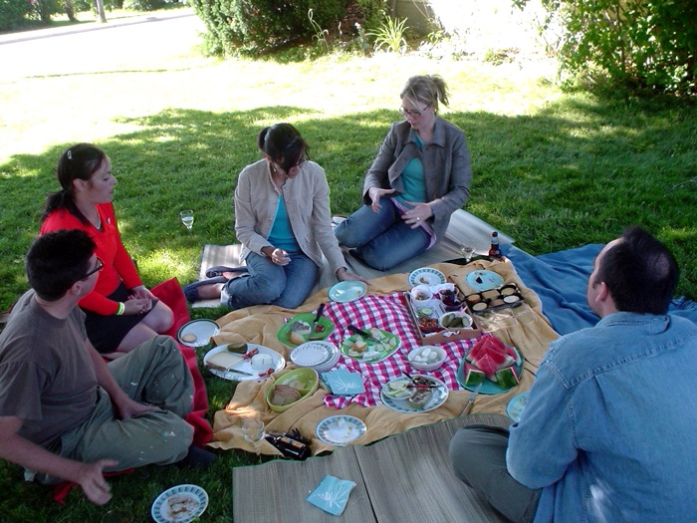
Church Picnic

Do you have next year’s calendar up already?
Mark in Sunday 31 January –
Church Picnic.
We are going to a new venue.

More details later.

Lindis-Fair.

At our event last week end we raised $2000.09
Thank you to everyone who helped.

ROSTER FOR SUNDAY DUTIES
Sunday |  | December 13th | December 20th |  | December 27th |  | January 3rd
DOOR AND WELCOME |  | Neil and Daphne  Salter | Margaret Brass |  | Christine Frame  Barbara Richardson |  | Jessie Campbell  Betty Snell
VAN |  | Bryon King | Ian Findlay |  | Daphne Salter |  | Sharon Taylor
MORNING TEA |  | Ita and Runi Safole | Daphne and Neil Salter |  | Bryon and Dorothy King |  | Judith Stevens  Sarah Jenkin
FLOWERS |  | Raewyn Birss | Nicol Macfarlane |  | Ita Safole |  | Jessie Campbell
NOTICES | Evelyn Cruickshank |  |  | Carolyn McDonald. |  | Evelyn Cruickshank |  | Sarah Jenkin
CRECHE |  | School Holidays

CENTRE DUTIES
WEEK OF | LAWNS | SECURITY
December 14th – December 20th | Chris McDonald | Tony Weston
December 21st – December 27th | Neil Salter | Runi Safole
December 28th - January 3rd | Findlay Collie | Eddie Bremer
January 4th – January 10th | Lester Dean | Margaret Brass

Some Invercargill Parish Key Personnel

Presbyter & Parish Council Chairman Reverend Peter Taylor 216 0281
Parish Council Secretary Carolyn Weston
Parish Stewards Sarah Jenkin, Evelyn Cruickshank, Carolyn McDonald
Treasurer David Little
Parish Council Congregational Representatives
Margaret Brass, Darren Weston, (Mags Kelly)
Bookings Phone Office 216 0281
Prayer Chain Co-ordinator Joan Farley
Bulletin Editors Peter Lankshear, Margaret Brass
Committee Convenors
Pastoral/Outreach – Noeline Collie (Pastoral Care Team – Betty Snell)
Finance/Property – Cam McCulloch (Health & Safety – Darren Weston)
Worship/Education – Neil Cruickshank

