Bulletin
The Invercargill Parish of the Methodist Church of New Zealand.
Te Hahi Weteriana o Aotearoa.
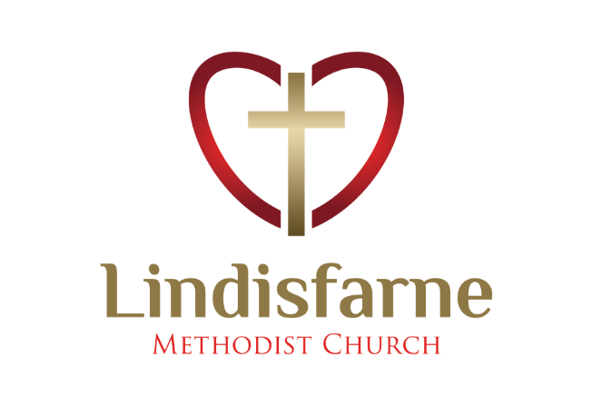
Lindisfarne Methodist Church, Worship and Community Centre.
22 Lindisfarne Street. Invercargill 9812 Phone 216-0281.
e-mail: office@lindisfarne.org.nz Website: www.lindisfarne.org.nz
Lindisfarne Methodist Church.

Sunday February 6th 2022.

10.00am: Lindisfarne Covenant and Communion Service led by Reverend Tania Shackleton.

1.00pm Tongan Service

Prayer:
My joy will make you strong.
Don’t be dejected and sad, for the joy of the lord is your strength.
Nehemiah 8:10.
I the Lord always want you to be filled with peace and joy, but I know that it is not always going to happen.
When life is hard and things aren't going the way you want them to, I know you get frustrated and angry.
It's ok to feel that way, but I don't want you getting stuck in your feelings.

I give you hope---- there is no reason to stay stuck in feeling empty and sad.
When you feel weak and you start to doubt, pray to me and I will strengthen you and give you joy.

Calendar
Sunday 6th  February | 10.00am  1.00pm | Lindisfarne Covenant and Communion Service led by Reverend Tania Shackleton.  Tongan Service
Wednesday 9th | 6.30pm  7.30pm | Health and Safety Committee.  Choir Practice.
Thursday 10th | 10.00am  1.30pm | Knitting Group.  Sit and be Fit.
Sunday 13th  February | 10.00am  1.00pm  1.00pm | Lindisfarne Service led by Rev.Tania Shackleton.  Tongan Service.  Fijian Service.

Centre Secretary
We welcome our new office secretary, Laura Mackie.
She is not yet familiar with all our comings and goings, so please be kind.

Today’s Service

Our Order of Service is displayed by the overhead projector.
Congregational responses are printed in yellow, and if you are able, please stand for the hymns and offering prayer.

~~~~~~~~~~~~~~~~~~~~~~~~
Anagrams
Dating back to ancient Greece, creating anagrams has long
been a popular pastime.
An anagram is a word or phrase formed by rearranging the letters of a different word or phrase, typically using all the original letters.
Word puzzles and Scrabble are derived from anagrams.
The word anagram itself can be rearranged into nag a ram, also the word binary into brainy and the word adobe into abode.
Most results are unspectacular, but sometimes they can be very surprising, clever or even funny.

Word or Phrase | Anagram
Mother in Law | Woman Hitler
Presbyterian | Best in prayer
Astronomer | Moon Starter
The eyes | They see
Election results | Lies lets recount
Snooze alarms | Alas no more Z’s
A decimal point | I’m a dot in place
The earthquakes | That queer shake
Animosity | Is no amity
Eleven plus two | Twelve plus one
McDonalds | Damn clods
Lindisfarne | Final diners

Computers facilitated the creation of anagrams dramatically and programmes are readily available on the internet.
Using one of these for the word Lindisfarne produced an astounding 560 different phrases!!
ROSTER FOR SUNDAY DUTIES.
Sunday | February 6th | February 13th | February 20th | February 27th
DOOR | Noeline Collie  Barbara Richardson | Evelyn Cruickshank | Carolyn and Chris McDonald | Dot Anderson Margaret Brass
VAN | Bryon King | Daphne Salter | Ian Findlay | Findlay Collie
MORNING TEA | Nicol Macfarlane  Beverly Service | Betty Snell  Noeline Szabo | Ita and Runi Safole | Annette and David Little
FLOWERS | Dorothy King | Mags Kelly | Dot Anderson | Betty Snell
NOTICES | Evelyn | Carolyn | Barbara | Evelyn
CRECHE | Petra Weston | Carol McKenzie | Betty Snell | Amanda Hare
KIDS KLUB | Waitangi Day | Fun Sunday | Carla Werder | Victoria Safole

CENTRE DUTIES
WEEK OF | LAWNS | SECURITY
February 7th – February 13th | Ian Findlay | Eddie Bremer
February 14th – February 20th | Nicol Macfarlane | Tony Weston
February 21st -February 27th | Lester Dean | Darren Weston
February 28th – March 6th | Runi Safole | Cam McCulloch

TODAY
COMMUNION | Raewyn Birss, Neil Salter

SOME INVERCARGILL PARISH KEY PERSONNEL
Minister Reverend Tania Shackleton
Parish Council Secretary Carolyn Weston
Parish Stewards Carolyn McDonald, Evelyn Cruickshank, Barbara Richardson
Parish Council- Chairman TBA |  |  | Treasurer David Little
Prayer Chain Co-ordinator |  | Mags Kelly
Bulletin Editors | Peter Lankshear Margaret Brass
Committee Conveners
Pastoral Care: Betty Snell Finance/Property: Cam McCulloch
Pastoral/Outreach: Noeline Collie Worship/Education: TBA
Health and Safety. Darren Weston

Congregational Representatives
Margaret Brass
Nicol Macfarlane Sarah Jenkin

