Lindisfarne Bulletin

The Invercargill Parish of the

Methodist Church of New Zealand.

**Te Hahi Weteriana o Aotearoa.**

***Lindisfarne Methodist Church, Worship and Community Centre****.*

*Phone 216-0281.*

*e-mail:* [*office@lindisfarne.org.nz*](mailto:office@lindisfarne.org.nz)*. Website:* [*www.lindisfarne.org.nz*](http://www.lindisfarne.org.nz)



**Sunday June 14th 2015**

10.00am: Lindisfarne Service with Judy Johnson.

10.00am: Bluff Service with Neil Salter.

1.00pm: Fijian Service.

1.00pm: Tongan Service.

2.00pm: Peacehaven Service with Nicol Macfarlane.

Prayer*:*

*We pray for those who through ill health and age cannot attend our regular services, that they may still find peace and comfort.*

|  |  |  |
| --- | --- | --- |
| *.*Lindisfarne Calendar | | |
| Sunday 14th  June | 10.00am  10.00am  1.00pm  1.00pm  2.00pm | Lindisfarne Service with Judy Johnson.  Bluff Service with Neil Salter.  Fijian Service.  Tongan Service.  Peacehaven Service with Nicol Macfarlane. |
| Monday 15th | 3.30pm  7.30pm | Story Room.  Study Group at Kings' - 44 George Street. |
| Tuesday 16th | 3.30pm | Story Room. |
| Wednesday  17th | 7.00pm  7.30pm | North Invercargill Bowls.  Choir Practice, followed by AGM and Supper. |
| Thursday 18th | 11.30am  1.30pm  7.00pm | Pastoral Care Team meeting.  Sit and Be Fit.  Blues Bowling Club. |
| Friday 19th | 4.30pm | Friday Club. |
| Sunday 21st June. | 10.00am  10.00am  1.00pm  4.30pm  4.30pm | Invercargill Service with Rachael Masterton.  Riverton Service with Nicol Macfarlane.  Tongan Service.  Southland Competitions Society.  North Inner Wheel. |

**Fundraising**

Our next fundraiser will be **Cheese Rolls**. We will be making them on **Thursday 6th (evening) and Saturday 8th (morning) of August**. Mark those dates in your diary. You can help now by letting friends, family, workmates, neighbours etc that this is happening. Order forms will be available at the end of this month.

And while you have your diary open, mark in **Garage Sale** on the **31st of October**.

 _________________________________________________________

**Questions**

If lawyers are disbarred and clergymen defrocked, then doesn't it follow that electricians can be delighted, musicians denoted, cowboys deranged, models deposed, tree surgeons debarked, and dry cleaners depressed?

**A Great Achievement**

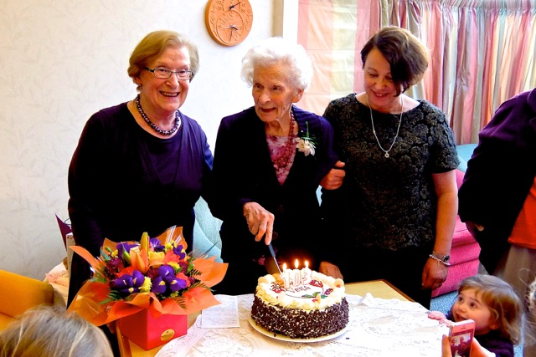

**Congratulations to Betty Snell's mother Vera Wilkie who celebrated her 103rd birthday on the 4th of June. With her are daughter Betty, granddaughter Biddy O'Sullivan and great granddaughter Debbie.**

**An Invitation to Everyone**

On the evening of **Saturday 27th June** we will join in a Shared Meal. Please sign the list in the foyer today or, at the latest, next Sunday if you are coming.

To share the catering load, you are invited to bring a salad or a dessert plus $5. Or you may choose to pay $10 and let others provide the food!

**Another Invitation**

If you would like to go to the Invercargill Musical Theatre’s **“Phantom of the Opera”** but not on your own, here is your opportunity.

**Wednesday 15th July at 7.30 pm** or **Sunday 19th July at 4.00 pm.**

Choose your day, sign the green sheet in the foyer, bring your money in an envelope with your name and the chosen date and give it to Raewyn Birss or Betty Snell.

We will book your seat as soon as your money is in. (Cash only please). Senior citizens (65 and over) $60, other adults $70, children $40. These prices include booking fees.

The seats will be downstairs. Transport will be available in the church van.

Wednesday seats are filling fast.

ROSTER FOR SUNDAY DUTIES

|  |  |  |  |  |
| --- | --- | --- | --- | --- |
| **SUNDAY** | **June 14th** | **June 21st** | **June 28th** | **July 5th** |
| **DOOR AND**  **WELCOME** | Betty Snell  Daphne Salter | Joe and Catherine Wilson | Maka Family | Hilda Fife Margaret Brass |
| **VAN DRIVER** | Eddie Bremer | Ron Taylor | Bryon King | Murray Gibbs |
| **FLOWERS** | Betty Snell | Dorothy King | Raewyn Birss | Ita Safole |
| **MORNING TEA** | Noeline and Findlay Collie | Bryon and Dorothy King | Sharon Taylor Carolyn McDonald | Keith and Carol McKenzie |
| **NOTICES** | Carol McKenzie | Eddie Bremer | Betty Snell | Carol McKenzie |
| **CRECHE** | Sharon Taylor | Betty Snell | Susanne Staples | School Holidays |
| **KIDS KLUB** | TBA | Susanne Staples | Susanne Staples | School Holidays |

CENTRE DUTIES

|  |  |  |
| --- | --- | --- |
| **WEEK OF** | **LAWNS** | **SECURITY** |
| **June 15th - June 21st** | Lester Dean | Joe Wilson |
| **June 22nd - June 28th** | Bryon King | Bryon King |
| **June 29th - July 5th** | Tapani Maka | Margaret Brass. |
| **July 6th - July 12th** | Findlay Collie | Hartley Hare |

SOME INVERCARGILL PARISH KEY PERSONNEL

|  |  |  |  |  |  |
| --- | --- | --- | --- | --- | --- |
| **Minister** Reverend Peter Taylor 216-0281 | | | | | |
| **Parish Secretary** Verna Eason | | | | | |
| **Parish Stewards** | Carol McKenzie Betty Snell Eddie Bremer | | | | |
| **Parish Council Chairman** Reverend Peter Taylor | | | | | **Treasurer**  David Little |
| **Parish Council-**  **Congregational Representatives** | | | | Margaret Brass  Nicol Macfarlane  Mags Kelly | |
| **Prayer Chain Co-ordinators** | | | Joan and Murray Farley. | | |
| Bulletin Editors | | Peter Lankshear  Margaret Brass | | | |
| Affordables Shop Manager Carolyn 216-9676 | | | | | |