Bulletin
The Invercargill Parish of the
Methodist Church of New Zealand.
Te Hahi Weteriana o Aotearoa.

Lindisfarne Methodist Church, Worship and Community Centre.
Phone 216-0281.
e-mail: office@lindisfarne.org.nz Website: www.lindisfarne.org.nz

Sunday 19th January 2020.

10.00am: Lindisfarne Service with Nicol Macfarlane.

10.00am: Bluff Service with Neil Salter.

1.00pm: Tongan Service.

Prayer:
When Jesus comes, the shadows depart. (On a castle wall in Scotland).
Loving God, we have joined with the angels celebrating Christ’s birth; inspire us anew to approach another new year with joy and the love of Jesus, who casts fear and shadows away.

Calendar
Sunday 19th January. | 10.00am  10.00am  1.00pm | Lindisfarne Service with Nicol Macfarlane.  Bluff Service with Neil Salter  Tongan Service.
Monday 20th | 1.00pm | Oranga Tamariki
Tuesday 21st | 5.00pm  7.00pm | Finance and Property Committee.  Worship and Education Committee.
Wednesday 22nd | 1.00pm  6.30pm | Outreach and Pastoral Committee.  Health and Safety Committee.
Sunday 26th January | 10.00am  1.00pm  1.00pm  5.00pm | Lindisfarne Service with Reverend Peter Taylor.  Tongan Service.  Fijian Service.  Private Booking.

Lindisfarne Methodist Pens
Still a few for sale at $2 each or five for $10. Red, light blue, dark blue, orange or yellow, all with blue ink. Sorry, no pink or green pens.

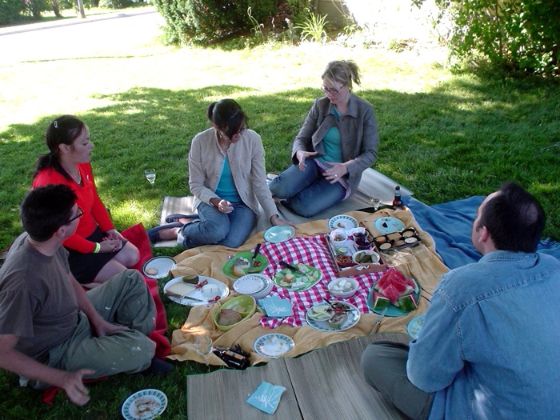
PICNIC!

Everyone is invited to the church family picnic at Anderson Park after the service on 2nd February. Bring your own food. Hot water available.

Office Hours
The Lindisfarne Office will be open this coming week
Monday, Wednesday and Friday from 9.30 am to 12.45pm
_______________________________




ROSTER FOR SUNDAY DUTIES
Sunday | January 19th | January 26th |  |  | February 2nd | February 9th
DOOR AND  WELCOME | Neil and Daphne Salter | Margaret Brass  Christine Frame |  |  | Raewyn Birss  Jessie Campbell | Dot Anderson
VAN | Daphne Salter | Sharon Taylor |  |  | Findlay Collie | Bryon King
FLOWERS | Nicol Macfarlane | Ita Safole |  |  | Raewyn Birss | Dorothy King
MORNING TEA | Nicol Macfarlane  Carol Chinpoy |  | Dorothy and Bryon King |  | Judith Stevens Sarah Jenkin | Beverly Service  Raewyn Birss
NOTICES | Sarah Jenkin | Noeline Collie |  | Evelyn Cruickshank |  | Noeline Collie
CRECHE | School Holidays | School Holidays |  |  | Sharon Taylor | Amanda Hare
KIDS KLUB | School Holidays | School Holidays |  |  | TBA | TBA

CENTRE DUTIES
WEEK OF | LAWNS | SECURITY
January 20th - January 26th | Nicol Macfarlane | Runi Safole
January 27th – February 2nd | Runi Safole | Eddie Bremer
February 3rd - February 9th | Bryon King | Bryon King
February 10^{th -} February 16th | Chris McDonald | Darren Weston

Some Invercargill Parish Key Personnel

Minister & Parish Council Chairman Reverend Peter Taylor 216 0281
Parish Council Secretary Carolyn Weston
Parish Stewards Noeline Collie, Sarah Jenkin, Evelyn Cruickshank
Treasurer David Little
Parish Council Congregational Representatives
Margaret Brass, Mags Kelly
Bookings Phone Office 216 0281
Prayer Chain Co-ordinator Joan Farley
Bulletin Editors Peter Lankshear, Margaret Brass
Committee Convenors
Pastoral/Outreach – Noeline Collie (Pastoral Care Team – Betty Snell)
Finance/Property – Cam McCulloch (Health & Safety – Darren Weston)
Worship/Education – (Peter Taylor)

