Bulletin
The Invercargill Parish of the
Methodist Church of New Zealand.
Te Hahi Weteriana o Aotearoa.
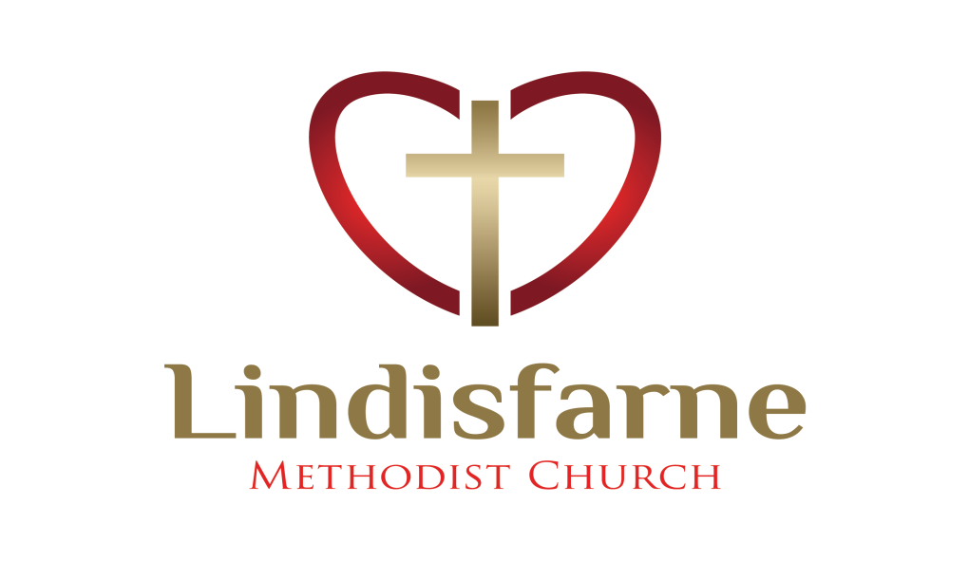
Lindisfarne Methodist Church, Worship and Community Centre.
Phone 216-0281.
e-mail: office@lindisfarne.org.nz Website: www.lindisfarne.org.nz

Sunday 1st July 2018.

10.00am: Lindisfarne Communion Service led by the Reverend Peter Taylor.

Parish Lunch to Follow.

1.00pm: Tongan Service.

Prayer: .
We pray for the folk who cannot afford enough food and heat for their families this winter. May we be generous with our plenty.
Thank you Lord for all Your Blessings.

Lindisfarne Calendar
Sunday 1st July | 10.00am  1.00pm | Lindisfarne Communion Service with Reverend Peter Taylor. Parish Lunch to follow.  Tongan Service.
Monday 2nd | 3.30pm  5.30 pm | Story Room.  Girl Guiding New Zealand.
Tuesday 3rd | 9.00am  9.00am  3.30pm  6.00pm  7.45pm | Invercargill Club.  Presbyter and Parish Stewards.  Story Room.  Pastoral and Outreach Committee.  Ladies Evening Group.
Wednesday 4th | 10.30am  7.00pm  7.30pm | Knitting Group.  North Invercargill Bowls.  Choir practice.
Thursday 5th | 1.30pm  2.00pm  7.00pm | Sit and Be Fit.  Methodist Women’s Fellowship. Notice below.  Blues Bowling Club.
Friday 6th | 6.00pm | Games Evening.
Saturday 7th | 1.30pm  6.00pm | Macdonald and Weston.  Private Booking.
Sunday 8th July | 10.00am  10.00am  1.00pm  1.00pm  2.00pm | Lindisfarne Service with Reverend Peter Taylor.  Bluff Service with Neil Salter.  Tongan Service.  Fijian Service  Peacehaven Service with Reverend Peter Taylor.

Would you like to help?
If you would like to take a turn serving refreshments after funerals please sign the list in the foyer. All food is provided.
We will just need to set up, serve and tidy up for services held by Macdonald and Weston in our church.
This will be of benefit for church funds
Coming up - Fun Games Night
Remember our Games Night at 6.00 pm on Friday 6 July. Start with your own takeaway tea. Bring your card or board games or join in with others.

The Auction
Thank you for your support of this fundraiser. We made a profit of $2060.00.

Meals on Wheels
It’s our turn from 9 to 13 July.
As Amanda is away, please let Margaret know if you can help. We need to cover thirteen duties over the week.

People's Needs
The Pastoral Team would like to know when there are needs within the Church Community, such as someone in hospital.
In these instances, please contact one of the Parish Stewards.

Methodist Women’s Fellowship
The July meeting and A.G.M. of the Fellowship will commence at 2.00pm on Thursday 5th in the lounge. Devotions will be led by Eleanor, hostess will be Verna and the guest speaker Reverend Peter Taylor.
For transport, phone Dorothy or Betty.

Different Today!
The 300 ft high Statue of Liberty was a gift from the people of France to the U.S.A. and is an impressive sight on Liberty Island in New York Harbour. , Nearby on Ellis Island were once the busy immigrant reception facilities, welcoming numerous boatloads of refugees from across the Atlantic. Jewish - American poet Emma Zacharia was moved to compose a sonnet, part of which is inscribed on the base of the statue.

"Give me your tired, your poor,
Your huddled masses yearning to be free.
The wretched refuse of your teeming shore.
Send these, the homeless lost, to me.
I lift my lamp beside the golden door."

Donald Trump's ancestors were immigrants from the village of Kallstadt in the German Rhineland.
ROSTER FOR SUNDAY DUTIES
Sunday | July 1st | July 8th |  | July 15th |  | July 22nd
DOOR AND  WELCOME | Keith and Carol McKenzie | Betty Snell  Daphne Salter |  | Evelyn and Neil Cruickshank |  | Noeline and Findlay Collie
VAN DRIVER | Sharon Taylor | Eddie Bremer |  | Daphne Salter |  | Ian Findlay
FLOWERS | Nicol Macfarlane | Dorothy King |  | Mags Kelly | Beverley Robinson
MORNING TEA | Janice McLeod  Carolyn Clearwater |  | Noeline and Findlay Collie | Bryon and Dorothy King |  | Neil and Daphne Salter
NOTICES | Judith Stevens | Noeline Collie |  | Muriel McCulloch |  | Judith Stevens
CRECHE | Betty Snell | School Holidays |  | School Holidays |  | School Holidays
KIDS KLUB | Annette Little | School Holidays |  | School Holidays |  | School Holidays

DUTIES TODAY
COMMUNION | Beverly Service and Verna Eason
LUNCH | Keith and Carol McKenzie

CENTRE DUTIES
WEEK OF | LAWNS | SECURITY
July 2nd - July 8th | Ian Findlay | Margaret Brass
July 9th - July 15th | Runi Safole | Runi Safole
July 16th - July 22nd | Findlay Collie | Cam McCulloch
July 23rd - July 29th | Chris McDonald | Hartley Hare

Some Invercargill Parish Key Personnel

Minister & Parish Council Chairman Reverend Peter Taylor 216 0281
Parish Council Secretary Carolyn Weston
Parish Stewards Noeline Collie, Muriel McCulloch, Judith Stevens
Treasurer David Little
Parish Council Congregational Representatives
Margaret Brass, Mags Kelly, Beverly Service
Bookings Phone Office 216 0281
Prayer Chain Co-ordinators Joan and Murray Farley
Bulletin Editors Peter Lankshear, Margaret Brass
Committee Convenors
Pastoral/Outreach - Raewyn Birss (Pastoral Care Team – Betty Snell)
Finance/Property – Cam McCulloch Worship/Education – Carol McKenzie

