Lindisfarne Bulletin
The Invercargill Parish of the
Methodist Church of New Zealand.
Te Hahi Weteriana o Aotearoa.

Lindisfarne Methodist Church, Worship and Community Centre
Phone 216-0281.
e-mail: office@lindisfarne.org.nz. Website: www.lindisfarne.org.nz

Sunday June 12th 2016

10.00am: Lindisfarne Service with
Reverend Peter Taylor.

10.00am: Bluff Service with Nicol Macfarlane.

1.00pm: Tongan Service.

1.00pm: Fijian Service.
PRAYER
Dear God;
Thank you for the things I have in abundance.
Thank you for the things of which I have enough.
Thank you for the things that I lack, for they keep me trusting in your many blessings.

Lindisfarne Calendar
Sunday 12th June | 10.00am  10.00am  1.00pm  1.00pm.  2.00pm | Lindisfarne Service with Reverend Peter Taylor.  Bluff Service with Nicol Macfarlane.  Tongan Service.  Fijian Service.  Peacehaven Service with Reverend Peter Taylor
Monday 13th | 3.30pm | Story Room.
Tuesday 14th | 3.30pm  7.00pm  7.00pm | Story Room.  Preachers Meeting.  Cake Decorators.
Wednesday 15th | 7.00pm  7.30pm | North Invercargill Bowls  Choir Practice.
Thursday 16th | 11.30am  1.30pm  7.00pm  7.00pm | Mid-Week Service with Reverend Peter Taylor  See notice below.  Sit and Be Fit.  Blues Bowls.  South City Choir.
Saturday 18th | 1.00pm  5.00pm | Private Booking.  Multi Nations.
Sunday 12th June | 10.00am  1.00pm | Lindisfarne Service with Reverend Peter Taylor.  Tongan Service.

Mid-Winter Dinner Saturday 9th July.
Please fill in the list in the foyer by 2nd July.
Indicate whether you will bring a salad OR a dessert OR pay $10.

Mid-Week Service and Lunch Thursday 16th June.
The service, beginning at 11.30am, will be followed by the usual lunch.
Please tell Betty Snell or Dorothy King if you will be attending the lunch.

Congratulations!!

Betty Snell's mother, Mrs Vera Wilkie celebrated her 104th Birthday on June 4th.
Here is a photo of her looking remarkably spry despite having suffered a broken hip a fortnight previously. Betty is pleased to announce that Vera is making a good recovery.
______________________________________
A Thoughtful Contribution from Murray Farley

Those of us who live in Townhouses/ Cottages at Peacehaven have a standing invitation to afternoon tea in Iona wing (dementia) on the first Tuesday of each month. At the April gathering we were offered little scrolls with an Alzheimer’s prayer featured. This is the prayer:
Alzheimer’s Prayer
Please grant my visitors tolerance for my confusion,
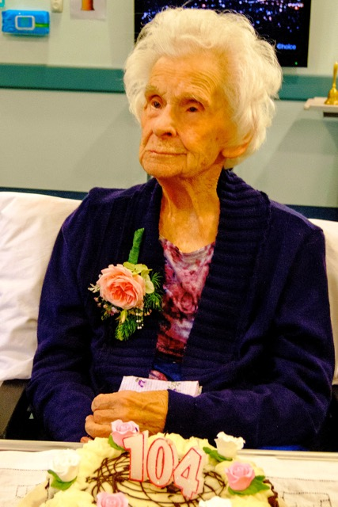
Forgiveness for my irrationality,
And the strength to walk with me into the mists of memory my world has become.

Please help them to take my hand and stay a while, even though I seem unaware of their presence.
Help them to know how their strength and loving care will drift slowly into the days to come
Just when I need it most.

Let them know when I don’t recognize them that I will, I will……………………………..
Keep their hearts free from sorrow for me
For my sorrow, when it comes, only lasts a moment: then it’s done.
And finally, Lord, let them know how very much their visits mean;
How even through this relentless mystery, I can still feel their love.
Author unknown.
ROSTER FOR SUNDAY DUTIES
Sunday | 12th June | 19th June | 26th June | 3rd July
DOOR AND  WELCOME | Noeline and Findlay Collie | Verna Eason  Raewyn Birss | Tony Weston  Nicol Macfarlane | Fay Brown  Dot Anderson
VAN DRIVER | Ian Findlay | Daphne Salter | Murray Gibbs | Sharon Taylor
FLOWERS | Bev. Robinson | Betty Snell | Mags Kelly | Dorothy King
MORNING TEA | Sharon Taylor  Susanne Staples | Carolyn McDonald  Judith Day | Mags Kelly  Betty Snell | Verna Eason  Raewyn Birss
NOTICES | Betty Snell | Muriel McCulloch | Eddie Bremer | Betty Snell
CRECHE | Dorothy King | Beth Gibbs | Dorothy King | Beth Gibbs
KIDS KLUB | Betty Snell | Betty Snell | Betty Snell | Carol McKenzie

CENTRE DUTIES
WEEK OF | LAWNS | SECURITY
13th June -19th June | Chris McDonald | Joe Wilson
20th June - 26th June | Neil Salter | Daphne Salter
27th June – 3rd July | Lester Dean | Cam McCulloch
4th July- 10th July | Eddie Bremer | Eddie Bremer

SOME INVERCARGILL PARISH KEY PERSONNEL
Minister Reverend Peter Taylor 216-0281
Parish Secretary Carolyn Weston
Parish Stewards | Betty Snell Eddie Bremer Muriel McCulloch
Parish Council Chairman Reverend Peter Taylor |  |  |  |  | Treasurer David Little
Parish Council-  Congregational Representatives |  |  |  | Margaret Brass  Mags Kelly
Prayer Chain Co-ordinators |  |  | Joan and Murray Farley.
Bulletin Editors |  | Peter Lankshear Margaret Brass

Affordables Shop Manager Carolyn 216-9676

