Bulletin
The Invercargill Parish of the Methodist Church of New Zealand.
Te Hahi Weteriana o Aotearoa.
Lindisfarne Methodist Church, Worship and Community Centre.
22 Lindisfarne Street. Invercargill 9812 Phone 216-0281.
e-mail: office@lindisfarne.org.nz Website: www.lindisfarne.org.nz

Lindisfarne Methodist Church

Sunday May 23rd 2021.

Pentecost

10.00am: Lindisfarne Service led by the Reverend Peter Taylor.

1.00pm Fijian Service.

Prayer:
You are the Lord God of Love, and your love was demonstrated by Jesus and taught by Paul and others through the ages.
May we demonstrate this love as a Christian fellowship, with tolerance and forgiveness, to be a good witness in our community.

Calendar
Sunday 23rd May | 10.00am  1.00pm | Lindisfarne Service led by the Reverend Peter Taylor.  Fijian Service.
Monday 24th | 8.30am  9.30am  5.30pm | Crestclean.  The Office of Ethnic Communities.  Girl Guiding New Zealand.
Tuesday 25th | 8.30am  7.00pm  7.00pm | Crestclean.  Kiribati Group Practice  Parish Council Meeting.
Wednesday 26th | 8.30am  11.30am  7.00pm  7.30pm | Crestclean.  Mid-Week Service.  North Invercargill Indoor Bowls.  Choir Practice.
Thursday 27th | 8.30am  10.00am  1.30pm  7.00pm | Crestclean.  Craft Circle.  Sit and Be Fit.  South City Choir Practice.
Friday 28th | 8.30am  7.00pm  8.00pm | Crestclean.  Kiribati Group Practice  Southland Alpine Garden Group.
Sunday 30th May | 10.00am  1.00pm | Lindisfarne Service led by the Reverend Peter Taylor.  Tongan Service.

“The way I see it, if you want the rainbow, you gotta put up with the rain.”- Dolly Parton

“You only live once, but if you do it right, once is enough.”
— Mae West

Parish Mid-Winter Dinner
Saturday June 12
5.45pm for a 6.00pm start.

Remember to put your name down on the list in the foyer or phone the office (216 0281) or Margaret (216 6175) by Sunday 6th June.
$20 for an adult, free for children accompanied by an adult.
Please make it easy for us by bringing-
cash in a named envelope.
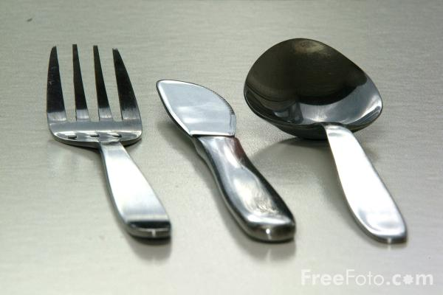

Cheese Rolls
Our next fund-raiser – our wonderful cheese rolls!
Order forms will be available next week.
Please tell your family and friends that they are coming -
(the order forms, that is, not the people!)
Because of the rising cost of ingredients and packaging we have reluctantly had to increase our selling price to
$8 a dozen or 4 dozen for $30.

An investment in knowledge always pays the best interest.
Be wiser than other people if you can. But do not tell them so.
-Ralph Waldo Emerson.

ROSTER FOR SUNDAY DUTIES.
Sunday | May 23rd | May 30th | June 6th | June 13th
DOOR AND WELCOME | Bryon King | Judith Stevens  Christine Frame | Dot Anderson  Raewyn Birss | Nicol Macfarlane  Margaret Brass
VAN | Eddie Bremer | Bryon King | Daphne Salter | Findlay Collie
MORNING TEA | Carolyn McDonald  Judith Day | Sarah Jenkin  Betty Snell | Beverly Service  Jo Templeton | Annette and David Little
FLOWERS | Betty Snell | Jessie Campbell | Nicol Macfarlane | Ita Safole
NOTICES | Carolyn McDonald | Sarah Jenkin | Carolyn McDonald | Carolyn McDonald
CRECHE | Petra Weston | Carol McKenzie | Queens Birthday | Carol McKenzie
KIDS KLUB | Carol McKenzie | Raewyn Birss | Queens Birthday | Annette Little

CENTRE DUTIES
WEEK OF | LAWNS | SECURITY
May 24th – May 30th | Runi Safole | Eddie Bremer
May 31st – June 6th | Chris McDonald | Darren Weston
June 7th – June 13th | Findlay Collie | Darren Weston
June 14th – June 20th | Neil Salter | Hartley Hare

Some Invercargill Parish Key Personnel

Presbyter & Parish Council Chairman Reverend Peter Taylor 216 0281
Parish Council Secretary Carolyn Weston
Parish Stewards Sarah Jenkin, Evelyn Cruickshank, Carolyn McDonald
Treasurer David Little
Parish Council Congregational Representatives
Margaret Brass, Mags Kelly, Darren Weston
Bookings Phone Office 216 0281
Prayer Chain Co-ordinator Mags Kelly
Bulletin Editors Peter Lankshear, Margaret Brass
Committee Convenors
Pastoral/Outreach – Noeline Collie (Pastoral Care Team – Betty Snell)
Finance/Property – Cam McCulloch (Health & Safety – Darren Weston)
Worship/Education – Neil Cruickshank

