Bulletin
The Invercargill Parish of the
Methodist Church of New Zealand.
Te Hahi Weteriana o Aotearoa.


Lindisfarne Methodist Church, Worship and Community Centre.
Phone 216-0281.
e-mail: office@lindisfarne.org.nz Website: www.lindisfarne.org.nz

Sunday 26th May 2019.

10.00am: Lindisfarne Service led by
the Reverend Peter Taylor.

1.00pm: Tongan Service.

Prayer:
Dear God, It is I, the Elephant, your creature, who is talking to you.
I am so embarrassed by my great self, and, truly, it is not my fault if I spoil your jungle with my big feet.
Let me be careful and behave wisely, always keeping my dignity and pose; give me such philosophic thoughts that I can rejoice wherever I go and laugh at the lovable oddity of things.
.
Calendar
Sunday 26th May | 10.00am  1.00pm | Lindisfarne Service led by the Reverend  Peter Taylor.  Tongan Service
Monday 27th | 3.30pm  5.30pm | Story Room.  Girl Guiding N.Z.
Tuesday 28th | 3.30pm  7.00pm | Story Room.  Parish Council Meeting
Wednesday 29th | 7.00pm  7.30pm | North Invercargill Bowls.  Choir Practice.
Thursday 30th | 8.00am  1.30pm  7.00pm  7.00pm | Oranga Tamariki  Sit and be Fit.  Blues Bowls.  South City Choir Practice.
Sunday 2nd June | 10.00am  1.00pm | Lindisfarne Communion Service led by the Reverend Peter Taylor. Parish lunch to follow.  Tongan Service

“Sometimes I think that the surest sign that intelligent life exists elsewhere in the universe is that none of it has tried to contact us”
Bill Watterson

Meals on Wheels
Please let Amanda know if you can help in the week of 10-14 June. We need extra drivers to cover the emergency spot.

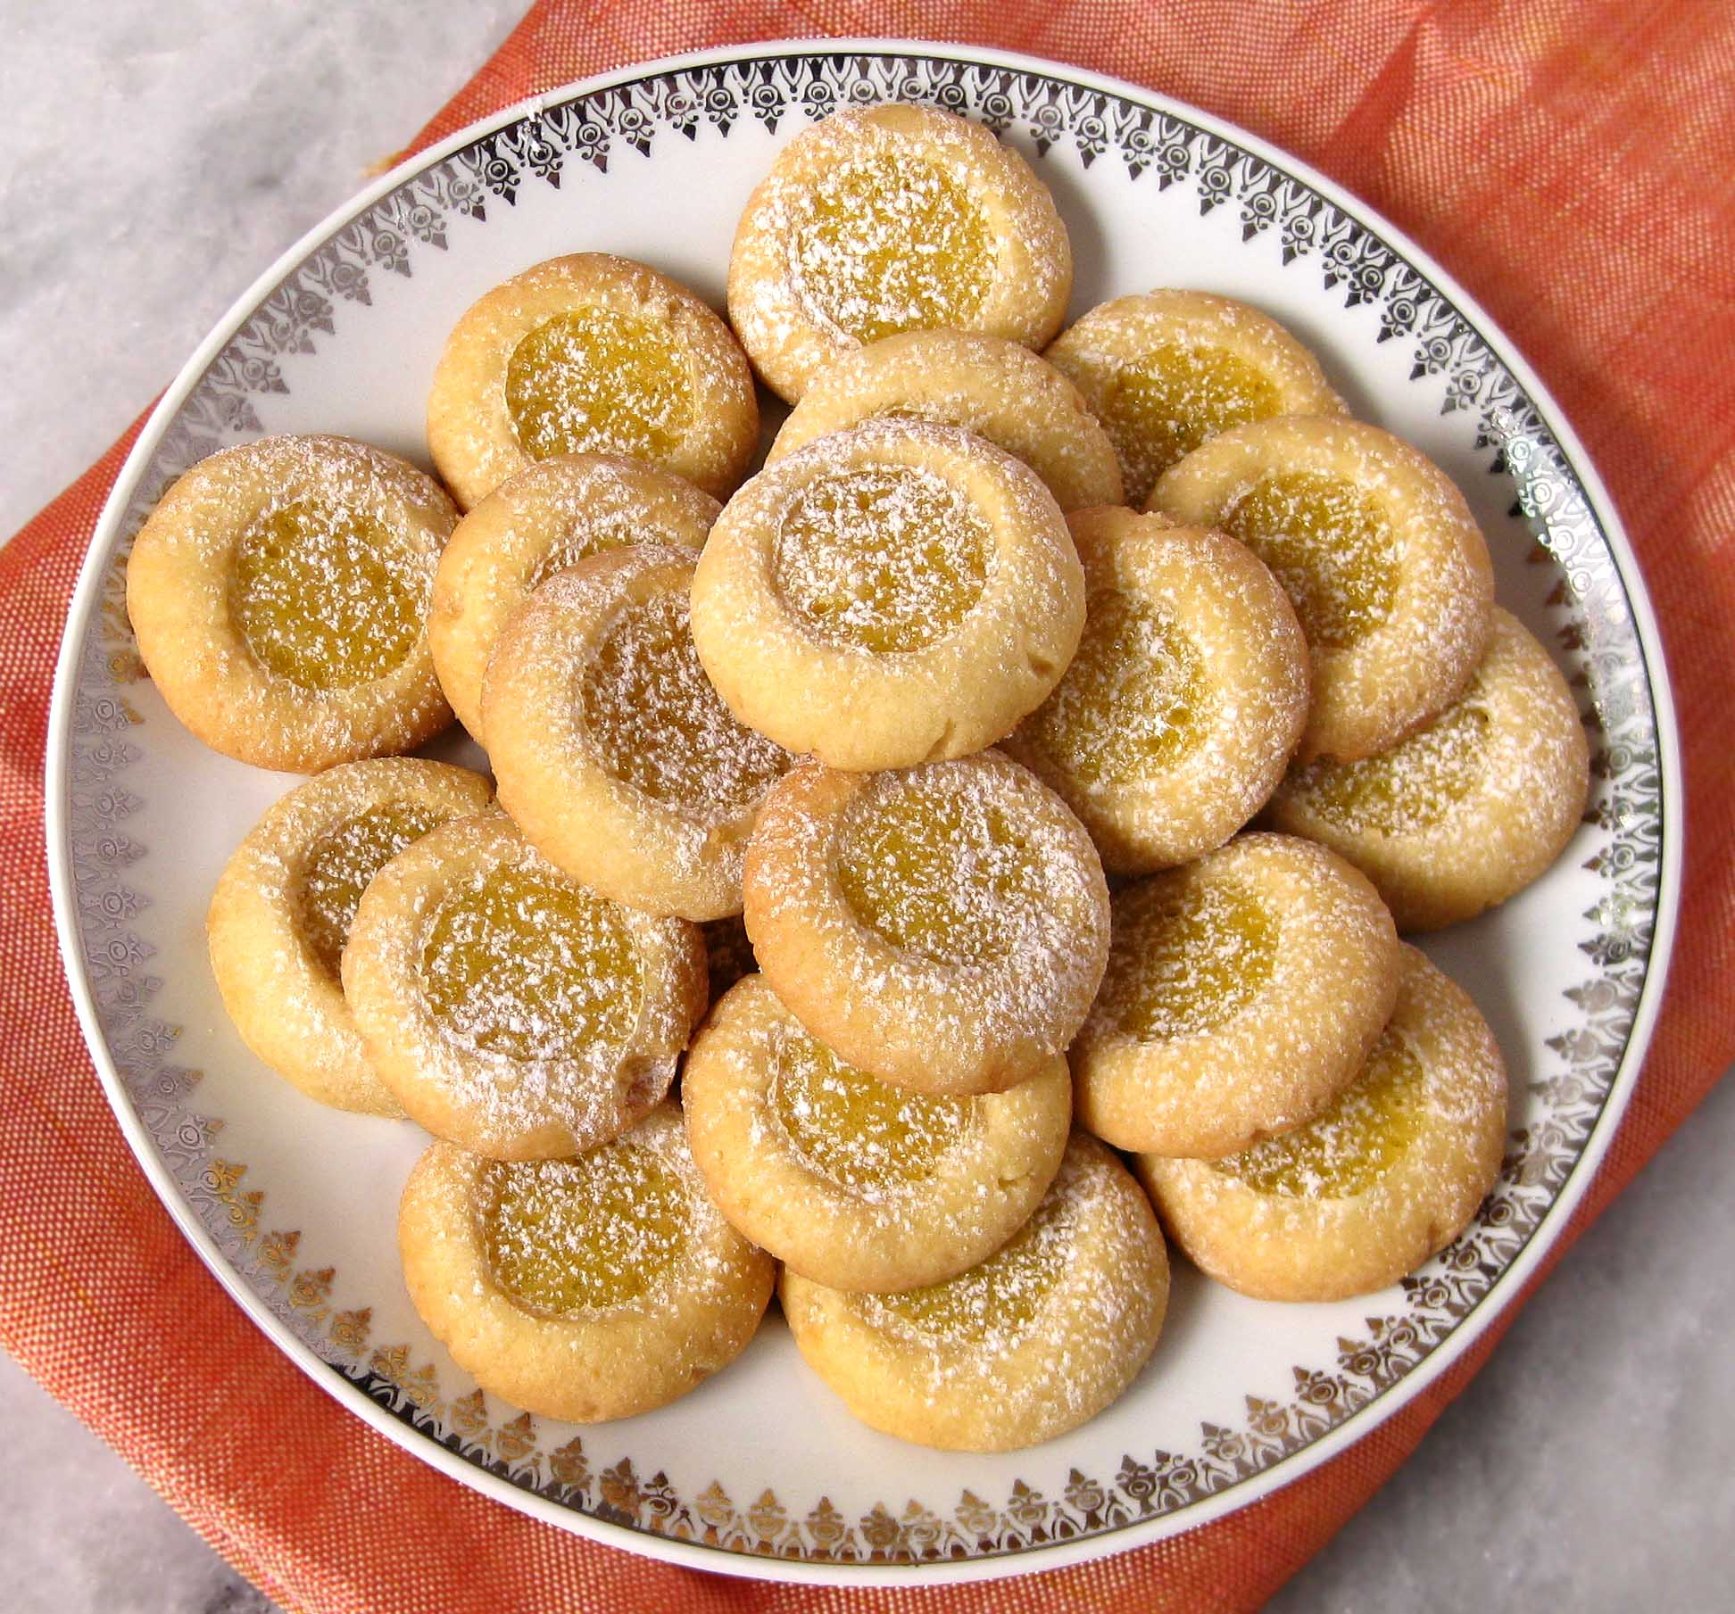
Fund Raising
Remember to order pies and biscuits made by Braemar Bakery. If you want to order just for yourself, take a white half-sheet. If you can get orders from other people, take and sign for a detailed form – white for biscuits, pink for pies. Order forms are in the foyer. They are due back by Wednesday 12th June.
Please bring the money in a named envelope.
The food will be available on Sunday 23rd June.

Also available on Sunday 23rd June will be order forms for cheese rolls, which we will be making on Thursday evening 25th and Saturday morning 27th July. Mark these dates in your diary.


Knitting Group
Anyone interested in knitting for others is invited to be part of a group who will meet with the craft group on the 2nd and 4th Thursday of each month from 10.00 am to 11.30am. We will be knitting scarves and beanies, baby clothes, knee rugs and, in response to a request from the Red Cross, hot water bottle covers for our Colombian refugees. There is some wool available. More wool would be appreciated during the winter months.

Garage Sale
If you have items for our November garage sale, but no place to keep them, please put them in the church storeroom whenever it suits you.

One Sunday morning our minister asked parishioners to stay after the service so he could “pick our brains’ about a forthcoming event. He was quick to add, “It should only take a minute.” Melody Rebenst

ROSTER FOR SUNDAY DUTIES
Sunday | May 26th | June 2nd | June 9th | June 16th
DOOR AND  WELCOME | Dot Anderson  Margaret Brass | Noeline and Findlay Collie | Betty Snell  Daphne Salter | Evelyn and Neil Cruickshank
VAN DRIVER | Ian Findlay | Findlay Collie | Eddie Bremer | Bryon King
FLOWERS | Ita Safole | Raewyn Birss | Betty Snell | Mags Kelly
MORNING TEA | Raewyn Hunt Beverly Service | Janice McLeod Carolyn Clearwater | Bryon and Dorothy King | Noeline and Findlay Collie
NOTICES | Noeline Collie | Judith Stevens | Noeline Collie | Sarah Jenkin
CRECHE | Dorothy King | Queens Birthday | Petra Weston | Beth Gibbs
KIDS KLUB | Carla Werder | Queens Birthday | Brendon and Rebecca Sparks | Hartley Hare

CENTRE DUTIES
WEEK OF | LAWNS | SECURITY
May 27th – June 2nd | Findlay Collie | Tony Weston
June 3rd - June 9th | Eddie Bremer | Eddie Bremer
June 10th – June 16th | Bryon King | Margaret Brass
June 17th – June 23rd | Neil Salter | Bryon King

DUTIES NEXT SUNDAY
COMMUNION | Noeline Collie and Mags Kelly
LUNCH | Dorothy and Bryon King

Some Invercargill Parish Key Personnel

Minister & Parish Council Chairman Reverend Peter Taylor 216 0281
Parish Council Secretary Carolyn Weston
Parish Stewards Noeline Collie, Sarah Jenkin, Judith Stevens
Treasurer David Little
Parish Council Congregational Representatives
Margaret Brass, Mags Kelly, Beverly Service
Bookings Phone Office 216 0281
Prayer Chain Co-ordinator Joan Farley
Bulletin Editors Peter Lankshear, Margaret Brass
Committee Convenors
Pastoral/Outreach - Raewyn Birss (Pastoral Care Team – Betty Snell)
Finance/Property – Cam McCulloch Worship/Education – Carolyn Clearwater

