Bulletin
The Invercargill Parish of the Methodist Church of New Zealand.
Te Hahi Weteriana o Aotearoa.
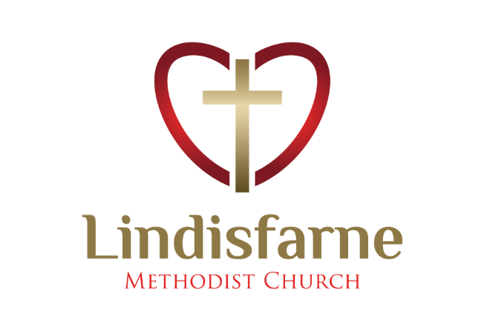
Lindisfarne Methodist Church, Worship and Community Centre.
Phone 216-0281.
e-mail: office@lindisfarne.org.nz Website: www.lindisfarne.org.nz

Lindisfarne Methodist Church

Sunday May 9th 2021.

10.00am: Lindisfarne Service led by the Reverend Peter Taylor.
(Mother’s Day, Pancake and Fun Sunday).

1.00pm: Tongan Service.

1.00pm: Fijian Service

2.00pm: Peacehaven Service led by the Reverend Peter Taylor.

Prayer: This week we remember our mothers with gratitude.
Thank you, Lord, for the blessings of family, and the influence a good mother can have. Bless those who are mothers now, and those who have gone before.

Calendar
Sunday 9th May | 9.00am  10.00am  11.30ish  1.00pm  1.00pm  2.00pm | Pancake Breakfast.  Lindisfarne Service led by the Reverend Peter Taylor.  (Mother’s Day, Pancake and Fun Sunday).  Presbyter Profile Meeting with Sarah.  Tongan Service.  Fijian Service.  Peacehaven Service led by the Reverend Peter Taylor.
Monday 10th | 9.00am  5.30pm | Imagine Better.  Girl Guiding New Zealand.
Tuesday 11th | 9.00am  2.00pm | Imagine Better.  Preachers Meeting.
Wednesday 12th | 1.00pm  7.00pm  7.30pm | Health and Safety Committee.  North Invercargill Indoor Bowls.  Choir Practice.
Thursday 13th | 10.00am  11.00am  1.30pm  2.00pm  7.00pm  7.00pm  7.00pm | Craft Circle.  Cargill Rest Home Service led by Rev Peter Taylor  Sit and Be Fit.  Pastoral Outreach Committee.  Fijian Church.  South City Choir Practice.  Blues Bowls.
Friday 14th | 11.00am  7.00pm | Lay Preacher seminar at Balclutha Presbyterian Church.  Fijian Church.
Saturday 15th | 12.00pm  4.00pm  9.00pm | Presbyter Profile Meeting.  Fijian Church.  Private Booking.
Sunday 16th May | 10.00am  10.00am  1.00pm  1.00pm | Lindisfarne Service led by Neil Salter.  Bluff Service led by the Reverend Peter Taylor.  Private Booking.  Tongan Service.
Duties Roster
At present there are blank spaces in some of the rostered duties listed in the Bulletin.
If you could fill one of these spaces, please tell Margaret or just do it.

Emergency Warden Training
There will be a further training session promptly after today’s service for those Door Stewards, and anyone else interested, who were not able to attend the sessions held in February.

Thank You
Thanks to the Outreach Committee for this morning’s pancake breakfast. A special event for Mothers Day!

Mother’s Day Cards
Small cards are on the foyer table:
They can be for yourself, your mother, or a mother you know.
Take them to keep, to pass on, or give away.

Diary Note
Keep free Saturday 12 June for our Winter Dinner.
More details soon!

And in July we will be making our famous cheese rolls.

ROSTER FOR SUNDAY DUTIES.
Sunday | May 9th | May 16th | May 23rd | May 30th
DOOR AND WELCOME | Chris McDonald  Tony Weston | Cam McCulloch  Jessie Campbell | Bryon King | Judith Stevens  Christine Frame
VAN | Ian Findlay | Findlay Collie | Eddie Bremer | Bryon King
MORNING TEA | Keith and Carol McKenzie | Sharon Taylor Christine Frame | Carolyn McDonald  Judith Day | Mags Kelly  Betty Snell
FLOWERS | Mags Kelly | Dot Anderson | Betty Snell | Jessie Campbell
NOTICES | Carolyn McDonald | Sarah Jenkin | Carolyn McDonald | Sarah Jenkin
CRECHE |  | Betty Snell | Petra Weston | Carol McKenzie
KIDS KLUB | Fun Sunday | Carol McKenzie | Carol McKenzie | Raewyn Birss

CENTRE DUTIES
WEEK OF | LAWNS | SECURITY
May 10th – May 16th | Nicol Macfarlane | Margaret Brass
May 17th – May 23rd | Lester Dean | Cam McCulloch
May 24th – May 30th | Runi Safole | Margaret Brass
May 31st – June 6th | Chris McDonald | Darren Weston

Some Invercargill Parish Key Personnel

Presbyter & Parish Council Chairman Reverend Peter Taylor 216 0281
Parish Council Secretary Carolyn Weston
Parish Stewards Sarah Jenkin, Evelyn Cruickshank, Carolyn McDonald
Treasurer David Little
Parish Council Congregational Representatives
Margaret Brass, Mags Kelly, Darren Weston
Bookings Phone Office 216 0281
Prayer Chain Co-ordinator Mags Kelly
Bulletin Editors Peter Lankshear, Margaret Brass
Committee Convenors
Pastoral/Outreach – Noeline Collie (Pastoral Care Team – Betty Snell)
Finance/Property – Cam McCulloch (Health & Safety – Darren Weston)
Worship/Education – Neil Cruickshank

