Bulletin
The Invercargill Parish of the Methodist Church of New Zealand.
Te Hahi Weteriana o Aotearoa.
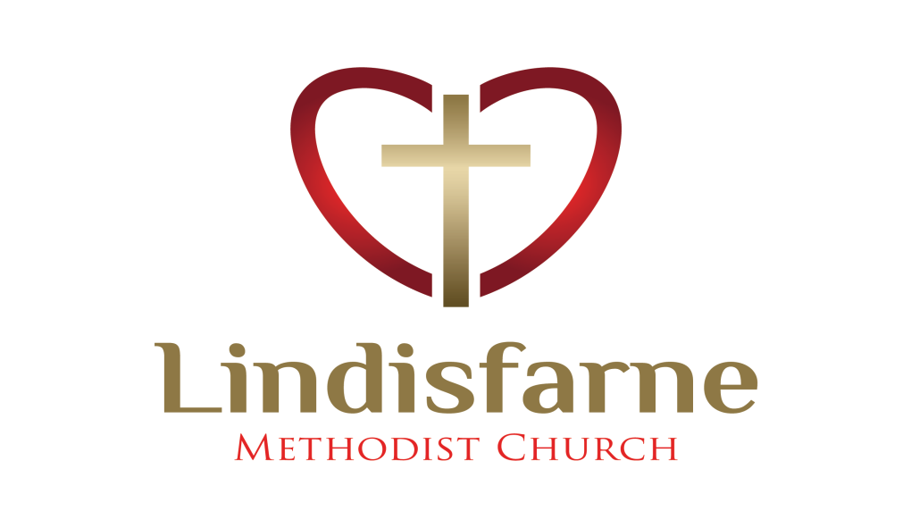
Lindisfarne Methodist Church, Worship and Community Centre.
Phone 216-0281.
e-mail: office@lindisfarne.org.nz Website: www.lindisfarne.org.nz


Lindisfarne Methodist Church

_________________________________________________________________

Sunday November 22nd 2020.

10.00am: Lindisfarne Service led by the Reverend Peter Taylor.

1.00pm: Tongan Service.

1.00pm: Fijian Service.
Prayer: Paul wrote ‘I pray that the eyes of your heart may be enlightened in order that you may know his incomparably great power’. (Ephesians 1:19)
Lord, when we sing about ‘Building a people of power’ may we confidently claim and know the great power which you have availed for us, to carry out your work here with joy.
Calendar
Sunday 22nd  November | 10.00am  1.00pm  1.00pm  7.00pm | Lindisfarne Service led by the Reverend Peter Taylor.  Tongan Service.  Fijian Service.  Private Booking.
Monday 23rd | 5.30pm | Girl Guiding New Zealand.
Tuesday 24th | 7.00pm | Parish Council Meeting.
Wednesday 25th | 7.30pm | Choir Practice.
Thursday 26th | 10.00am  7.00pm | Craft Circle.  South City Choir Practice.
Friday 27th | --------  7.00pm | Set up for Saturday’s Inner Wheel.  Storytellers Concert.
Saturday 28th | 9.00am  10.00am  7.00pm | Pink Possum Quilt Shop.  Inner Wheel.  English Language Partners.
Sunday 29th  November | 10.00am  1.00pm | Lindisfarne Service led by the Reverend Peter Taylor.  Tongan Service.

An Invitation
On Saturday 5th of December Eleanor Jillings will celebrate her
90th Birthday.
Anyone who would like to drop in to 143 Dalrymple St. between 12.00 and 4.00pm would be very welcome

Talent Challenge
On Sunday 29 November, as part of the Reverend Peter’s church Talent Challenge, Harper Dean will play her clarinet in the foyer before the service. Harper would appreciate any monetary support for her contribution.
(Harper is12 years of age and began clarinet lessons at school just before the Covid19 lock down began).

Christmas Hampers
Please support our preparation of special food hampers for families who would otherwise have a very lean time this Christmas.
They have been selected by “our” schools. You may choose to bring food such as tinned fruit, biscuits, sweets, jellies, soft drinks, Christmas cake or pudding.
Or you might make a cash donation and we will buy what is needed (at the best possible price!) Margaret will give you a receipt for donations of $5 or more, which you can use to claim a tax rebate.
As the parcels have to be delivered to the schools before their end of term, your contributions will be needed by the first week in December.

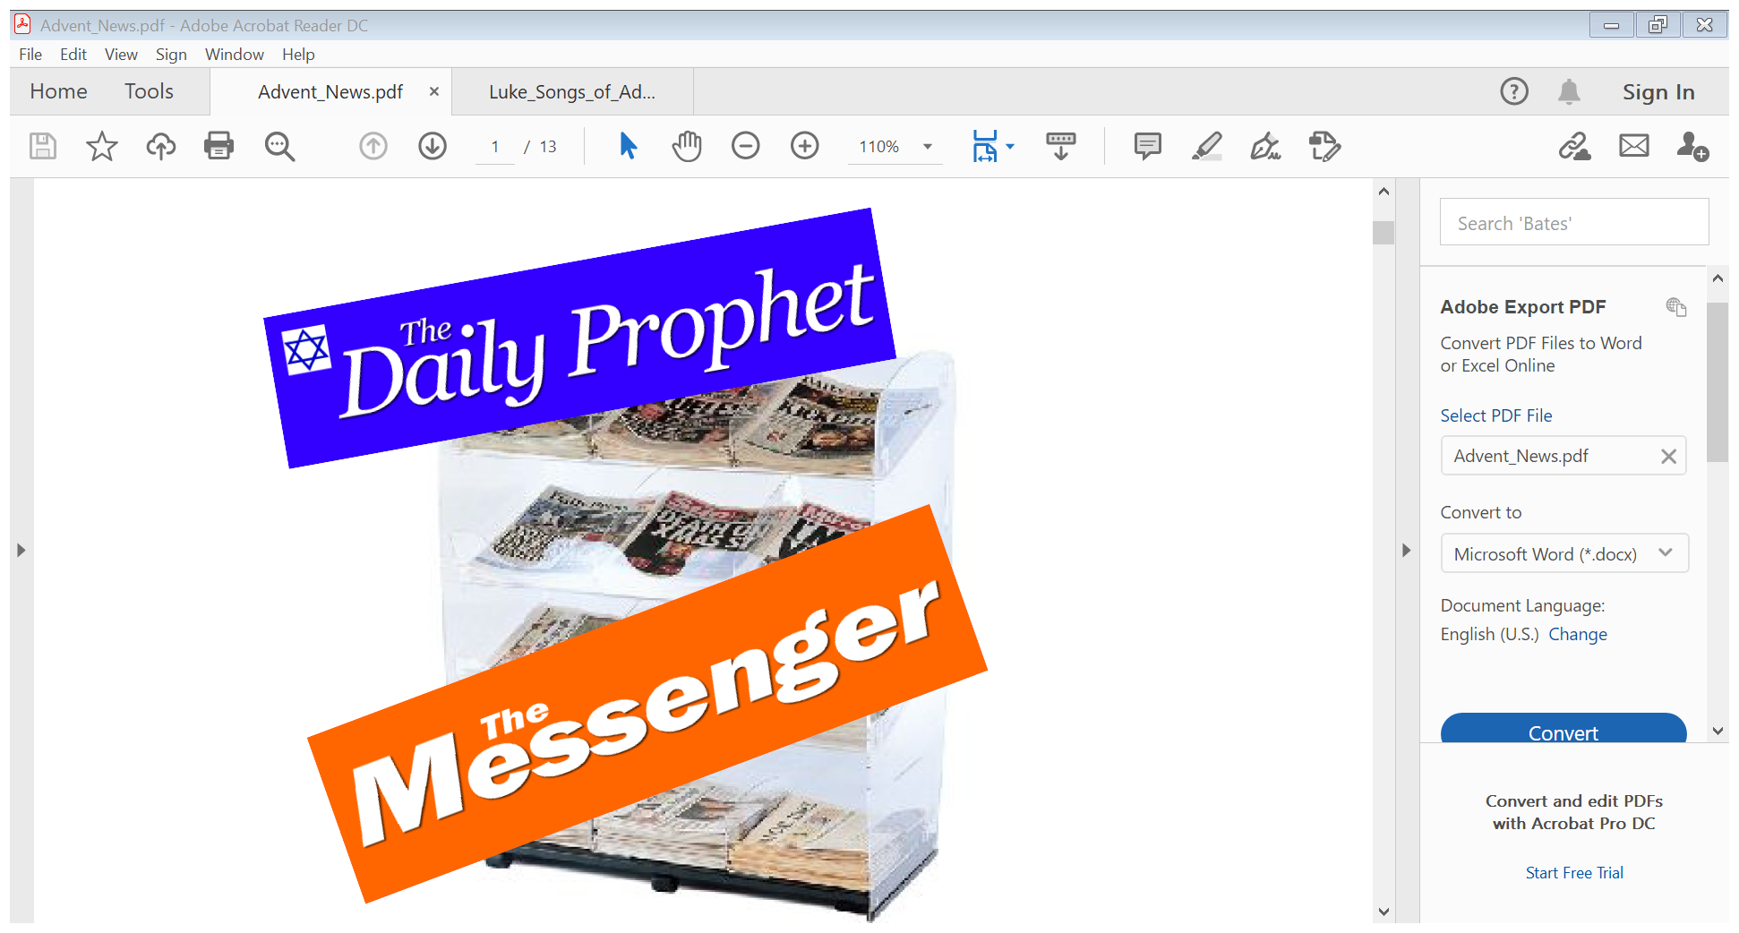
Advent Study
This year's Advent Study is called Read the News, and it imagines newspapers at the time of Jesus' birth and what they might have said about the events then.
There will be a group on Tuesday afternoons at 2.00 for four weeks from 1st December.


Ray Cohn
Ray Cohn, a brilliant but criminally dishonest attorney, was notorious for winning cases by delays, evasions, and lies. He was a young Donald Trump’s lawyer and mentor. Cohn’s philosophies included bullying, lying, hypocrisy, cheating, never admitting being wrong or at fault, and vindictively attacking critics.
Cohn, who was eventually disbarred claimed that Trump was his best disciple.

ROSTER FOR SUNDAY DUTIES
Sunday |  | November 22nd | November 29th | December 6th | December 13th
DOOR AND WELCOME |  | Muriel and Cam McCulloch | Bryon and Dorothy King | Raewyn Birss Dot Anderson | Carol Chinpoy  Margaret Brass
VAN |  | Ian Findlay | Sharon Taylor | Daphne Salter | Bryon King
MORNING TEA |  | Beverly Service  Christine Frame | Ita and Runi Safole | Nicol Macfarlane  Carol Chinpoy | Glenys and Ian  Findlay
FLOWERS |  | Mags Kelly | Dot Anderson | Betty Snell | Raewyn Birss
NOTICES | Evelyn Cruickshank |  | Sarah Jenkin | Carolyn McDonald | Evelyn Cruickshank
CRECHE |  | Dorothy King | Betty Snell | Amanda Hare | School Holiays

CENTRE DUTIES
WEEK OF | LAWNS | SECURITY
November 23rd – November 29th | Neil Salter | Cam McCulloch
November 30th – December 6th | Lester Dean | Eddie Bremer
December 7th -December 13th | Runi Safole | Bryon King
December 14th – December 20th | Chris McDonald | Tony Weston

Some Invercargill Parish Key Personnel

Presbyter & Parish Council Chairman Reverend Peter Taylor 216 0281
Parish Council Secretary Carolyn Weston
Parish Stewards Sarah Jenkin, Evelyn Cruickshank, Carolyn McDonald
Treasurer David Little
Parish Council Congregational Representatives
Margaret Brass, (Mags Kelly)
Bookings Phone Office 216 0281
Prayer Chain Co-ordinator Joan Farley
Bulletin Editors Peter Lankshear, Margaret Brass
Committee Convenors
Pastoral/Outreach – Noeline Collie (Pastoral Care Team – Betty Snell)
Finance/Property – Cam McCulloch (Health & Safety – Darren Weston)
Worship/Education – Neil Cruickshank

