Lindisfarne Bulletin
The Invercargill Parish of the
Methodist Church of New Zealand.
Te Hahi Weteriana o Aotearoa.

Lindisfarne Methodist Church, Worship and Community Centre
Phone 216-0281.
e-mail: office@lindisfarne.org.nz. Website: www.lindisfarne.org.nz

Sunday November 6th 2016

10.00am: Lindisfarne Communion Service
with Reverend Peter Taylor,

Parish Lunch to follow.

1.00pm: Tongan Service.
___________________________________________

If you know of someone who is in hospital, or has just come home from hospital, and wants someone to visit, please let Peter know, or inform one of the Parish Stewards (Judith Stevens, Muriel or Eddie).
Prayer:
Heavenly Father, bless this new month. We give thanks for your blessing on the people who have gone before us. May we cherish their memories and hold their love in our hearts.

Lindisfarne Calendar
Sunday 6th November | 10.00am  1.00pm | Lindisfarne Communion Service with Reverend Peter Taylor. Parish Lunch to follow.  Tongan Service.
Monday 7th | 3.30pm  5.30pm  7.30pm | Story Room.  Girl Guiding New Zealand.  Study Group at Kings', 44 George Street.
Tuesday 8th | 3.30pm | Story Room.
Wednesday  9th | 10.30am  7.30pm | Pastoral Care Team  Choir Practice
Thursday 10th | 10.00am  11.00am  1.30pm  7.00pm | Craft Circle.  Cargill Rest Home Service with Reverend Peter Taylor  Sit and Be Fit.  South City Choir practice.
Saturday 12th | 1.00pm  7.00pm | Maple Glen Visit.  Private Booking.
Sunday 13th November | 10.00am  1.00pm  1.00pm  2.00pm | Lindisfarne Service with Reverend Peter Taylor  Tongan Service.  Fijian Service.  Peacehaven Service with Reverend Peter Taylor

Thanks to everyone who helped with our successful Garage Sale yesterday.
Whether you gave us your unwanted goods to sell or bought someone else’s, helped to set up or to take down, made sales or sizzled sausages, your contribution was greatly appreciated.

November 12 – Garden visit to Maple Glen.
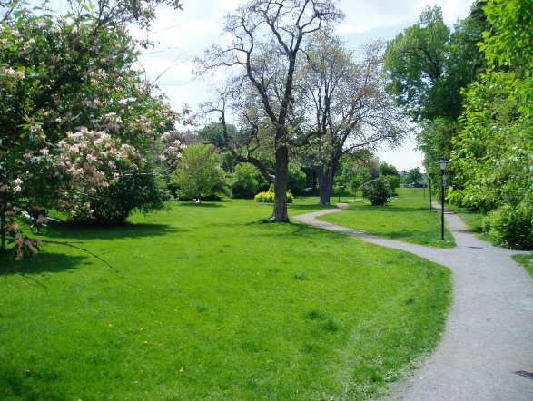
If you haven't already done so, please remember to sign the list in the foyer today, if you are planning to join the group visiting Maple Glen next Saturday. Also indicate whether you are willing to take a car.
We will share transport from the church leaving at 1.00 pm, spend about an hour and a half at the gardens, and return about tea-time.
Cost is just a donation or buy a plant.
If you are able to walk around the gardens, you should wear comfortable walking shoes. If you prefer to sit back and relax, you might like to bring a deck chair. The Outreach Committee will supply light refreshments for afternoon tea.
Time for a Smile

I started out with nothing and still have most of it.

My wild oats have turned to prunes and All Bran.

I finally got my head together; now my body is falling apart.

If all is not lost, where is it?

The Green Frog is Hungry

There has been considerable demand for Brown Bags, with a total of 14 going out this past month.
The spotted green frog that lives in the foyer is consequently very hungry at the moment.
He relishes small change and loves bank notes.

ROSTER FOR SUNDAY DUTIES
Sunday | November 6th | November 13th | November 20th | November 27th
DOOR AND  WELCOME | Ita and Runi Safole | Tony Weston  Nicol Macfarlane | Glenys and Ian Findlay | Margaret Brass  Dot Anderson
VAN DRIVER | Findlay Collie | Bryon King | Murray Gibbs | Ian Findlay
FLOWERS | Ita Safole | Nicol Macfarlane | Betty Snell | Mags Kelly
MORNING TEA | Judith Stevens  Fay Brown | C Clearwater  Hilda Fife | Beth Gibbs  Betty Snell | Janice McLeod  Carla Werder
NOTICES | Judith Stevens | Eddie Bremer | Muriel McCulloch | Judith Stevens
CRECHE | Amanda Hare | Sharon Taylor | Dorothy King | Betty Snell
KIDS KLUB | Hartley / Amanda Hare | Hartley / Amanda Hare | Carol McKenzie | TBA

DUTIES TODAY
COMMUNION | Noeline Collie and Hilda Fife
LUNCH | Raewyn Birss and Sharon Taylor

CENTRE DUTIES
WEEK OF | LAWNS | SECURITY
7th November - 13th November | Nicol Macfarlane | Tony Weston
14th November - 20th November | Chris McDonald | Hartley Hare
21st November -27th November | Ian Findlay | Margaret Brass
28th November -4th December | Runi Safole | Runi Safole

SOME INVERCARGILL PARISH KEY PERSONNEL
Minister Reverend Peter Taylor 216-0281
Parish Council Secretary Carolyn Weston
Parish Stewards | Eddie Bremer Muriel McCulloch Judith Stevens
Parish Council Chairman Reverend Peter Taylor |  |  |  |  | Treasurer David Little
Parish Council-  Congregational Representatives  Bookings Phone Office 216-0281 |  |  |  | Margaret Brass  Mags Kelly
Prayer Chain Co-ordinators |  |  | Joan and Murray Farley.
Bulletin Editors |  | Peter Lankshear  Margaret Brass

Affordables Shop Manager Carolyn 216-9676

