Lindisfarne Bulletin
The Invercargill Parish of the
Methodist Church of New Zealand.
Te Hahi Weteriana o Aotearoa.

Lindisfarne Methodist Church, Worship and Community Centre
Phone 216-0281.
e-mail: office@lindisfarne.org.nz. Website: www.lindisfarne.org.nz

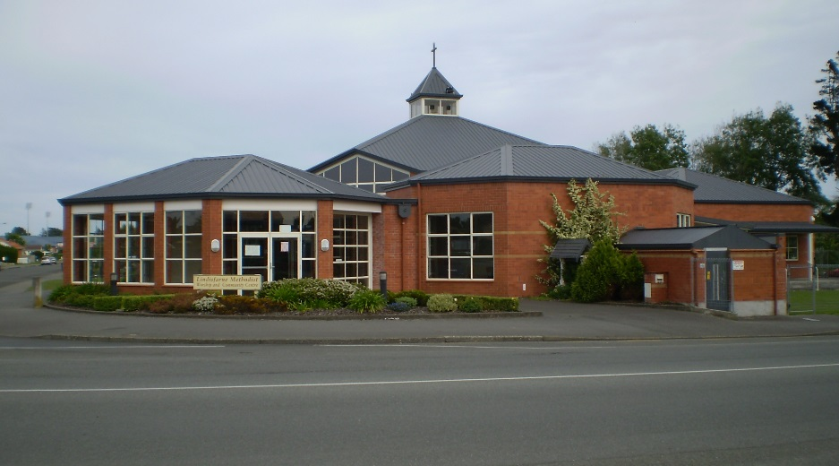

Sunday October 2nd 2016

10.00am: Lindisfarne Service with Dorothy Willis.
Parish Lunch to follow

1.00pm: Tongan Service.

***************
The Reverend Peter Taylor is at present attending the Methodist Church Conference.
Prayer: O Lord, you are the God of worlds yet unknown, and of times long past as well of all the future: yet you are also the God of here, and of now, and of us. Help us as we serve you in this present world, your witnesses for today, and heirs of eternity.

Lindisfarne Calendar
Sunday 2nd  October | 10.00am  1.00pm | Lindisfarne Service with Dorothy Willis.  Parish lunch to follow  Tongan Service.
Tuesday 4th | 9.00am  7.45pm | Invercargill Probus Club.  Ladies Evening Group.
Thursday 6th | 1.30pm  2.00pm | Sit and Be Fit.  Methodist Womens Fellowship at Peacehaven. See notice below.
Sunday 9th October | 10.00am  10.00am  1.00pm  1.00pm  2.00pm | Lindisfarne Communion Service with Reverend Peter Taylor  Bluff Service with Neil Salter.  Tongan Service.  Fijian Service.  Peacehaven Service with Reverend PeterTaylor.
.
Brown Bags
The green spotted pig is very hungry this week. We had five requests for Brown Bags last Friday/Saturday and another two on Tuesday. That’s 10 loaves of bread and 10 litres of milk as well as margarine, pies or sausages, fresh fruit and vegetables. Last week’s bags also contained 10 tins of baked beans, spaghetti, fruit and soup, seven of vegetables, along with pasta, jam, biscuits, cereal, toilet paper, soap, soap powder, rice. All recipients are vetted by an outside agency. No-one can just come and ask us for a Brown Bag!
Hint: Green pig eats banknotes as well as coins!

Pottles Please
Margaret requires clean margarine pottles again. Rectangular only, please.

Office hours/days for next week
The office will be closed on Monday 3rd October, but open Tuesday, Wednesday and Friday - at the usual hours of 8am to 1pm.

Reminders!
October 16th Hymn-along.
November 5th Garage Sale.
November 12th Garden Visit to Maple Glen.

Annual General Meeting
Our AGM will be held on Sunday 16th October.
Copies of the Annual Reports (July 2015–June 2016) are available for light bedtime reading. Collect your copy today.
One copy per family, please

Methodist Womens Fellowship.
To be held at on Thursday October 6th at 2pm.
in the lounge at Peacehaven, Tweed Street.
(Ask for directions at reception).
Devotions will be led by Judith and the hostess will be Betty.

Hymn-a-long
Hymn-a-long is to be held on Sunday, October 16th,
starting with a pot-luck tea at 6.00pm and singing at 7.00pm.
Please fill in the sheet in the foyer with the name of your favourite hymn or song so that we can enjoy singing them.
As there is limited time before the singing, please bring only food that doesn't require heating, or heat it at home and bring it along all ready for eating.
Finger food only, please.

ROSTER FOR SUNDAY DUTIES
Sunday | October 2nd | October 9th |  | October 16th | October 23rd
DOOR AND  WELCOME | Chris McDonald  Tony Weston | Hilda Fife  Christine Frame |  | Evelyn and Neil Cruickshank | Judith Stevens  Fay Brown
VAN DRIVER | Eddie Bremer | Findlay Collie |  | Daphne Salter | Sharon Taylor
FLOWERS | Beverley Robinson |  | Dorothy King | Mags Kelly | Raewyn Birss
MORNING TEA | Carolyn McDonald  Judith Day | Susanne Staples  Sharon Taylor |  | Mags Kelly  Betty Snell | Verna Eason  Raewyn Birss
NOTICES | Eddie Bremer | Muriel McCulloch |  | Betty Snell | Eddie Bremer
CRECHE | School Holidays | School Holidays |  | Susanne Staples | Labour Weekend
KIDS KLUB | School Holidays | School Holidays |  | TBA | Labour Weekend

Lunch duty today: Beth and Murray Gibbs
Communion next Sunday: Betty Snell and Mags Kelly

CENTRE DUTIES
WEEK OF | LAWNS | SECURITY
26th September - 2nd October | Ian Findlay | Joe Wilson
3rd October - 9th October | Runi Safole | Runi Safole
10th October -16th October | Neil Salter | Daphne Salter
17th October - 23rd October | Lester Dean | Cam McCulloch

SOME INVERCARGILL PARISH KEY PERSONNEL
Minister Reverend Peter Taylor 216-0281
Parish Council Secretary Carolyn Weston
Parish Stewards | Betty Snell Eddie Bremer Muriel McCulloch
Parish Council Chairman Reverend Peter Taylor |  |  |  |  | Treasurer David Little
Parish Council-  Congregational Representatives  Bookings Phone Office 216-0281 |  |  |  | Margaret Brass  Mags Kelly
Prayer Chain Co-ordinators |  |  | Joan and Murray Farley.
Bulletin Editors |  | Peter Lankshear Margaret Brass

Affordables Shop Manager Carolyn 216-9676

