Lindisfarne Bulletin
The Invercargill Parish of the
Methodist Church of New Zealand.
Te Hahi Weteriana o Aotearoa.

Lindisfarne Methodist Church, Worship and Community Centre
Phone 216-0281.
e-mail: office@lindisfarne.org.nz. Website: www.lindisfarne.org.nz

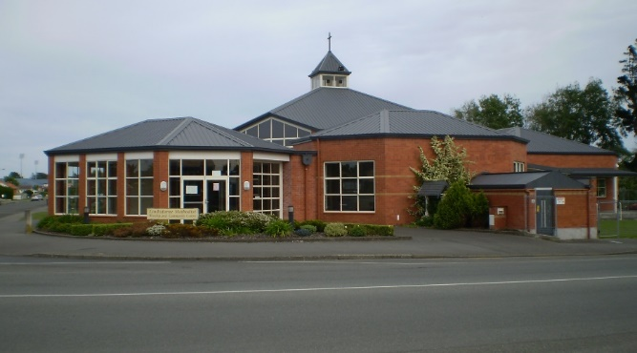

Sunday September 11th 2016

10.00am: Lindisfarne Service with Reverend Peter Taylor.

10.00am: Bluff Service with Nicol Macfarlane.

1.00pm: Tongan Service.

1.00pm: Fijian Service.

2.00pm: Peacehaven Service with Rev. Peter Taylor.

Prayer. (Psalm 23:4) Even when the way goes through Death Valley, I’m not afraid when you walk at my side.
God, we all forget Your promises and fall into worry and even fear. Show us in Your Scriptures and by Your Spirit the weapons of faith and trust which enable us to meet and to defeat the threats which beset us.
(from "The Message")

Lindisfarne Calendar
Sunday 11th September | 10.00am  10.00am  1.00pm  1.00pm  2.00pm | Lindisfarne Service with Reverend Peter Taylor.  Bluff Service with Nicol Macfarlane.  Tongan Service  Fijian Service.  Peacehaven Service with Rev. Peter Taylor.
Monday 12th | 3.30pm  5.30pm | Story Room.  Girl Guiding New Zealand..
Tuesday 13th | 9.00am  3.30pm  5.30pm | Fostering Kids.  Story Room.  Alzheimers Society.
Wednesday 14th | 7.00pm  7.30pm | North Bowls.  Choir Practice.
Thursday 15th | 1.30pm  7.00pm  7.00pm | Sit and Be Fit.  Blues Bowls.  South City Choir Practice.
Friday 16th | 1.00pm | Pastoral Care Team.
Sunday 18th September | 10.00am  1.00pm  3.00pm | Lindisfarne Service with Reverend Peter Taylor.  Tongan Service  Private Booking

"Historic Invercargill"
Bus Tour Saturday September 24th, leaving at 2.00pm
$10 per person for a two hour bus trip around the historic areas and buildings of Invercargill.
David Flack, a member of our congregation, is an experienced driver and tour guide and will share his wealth of knowledge and experience as our tour leader.
We have 40 seats available and would like to fill up the bus, so do invite your friends along.
Please write your name on the form provided in the foyer. One name for each line.
Please put your money in a named envelope, cash please,
and give to either Margaret Brass or Raewyn Birss.

Meals on Wheels
It is our turn again from the 19th of September to the 23rd of September. If anyone could spare an hour or so on one or more of those days, could they please contact Amanda

(Not a lot of drivers are needed this time. One for Monday and Tuesday, and two for Thursday and Friday).

Bible in Schools
Last Monday, our representative, Nicol Macfarlane, attended the A.G.M. of the Southland Christian Education Commission.

Of interest are some of the current statistics for Southland Bible in Schools. (State Primary Schools):
Total schools with Christian Religious Education (C.R.E.) .......44
Total children in C.R.E............................................................3792
C.R.E. teachers/helpers ..........................................................140
Single C.R.E. classes ................................................................21
Total children withdrawn..........................................................481

Emergency Food Parcels (Brown Bags)
Thank you to the people who regularly bring non-perishable goods for our Brown Bags. We are also very happy to receive gifts of money so we can buy the perishable food – bread, milk, margarine, fresh fruit and vegetables etc.
Even just a small donation is great. If five people gave 20 cents each week, that would be enough for a loaf of bread for someone in need. Just drop your “widow’s mite” into the green frog in the basket in the foyer.

ROSTER FOR SUNDAY DUTIES
Sunday | 11th September | 18th September | 25th September | October 2nd
DOOR AND  WELCOME | Evelyn and Neil Cruickshank | Noeline and Findlay Collie | Margaret Brass Mags Kelly | Hilda Fife  Christine Frame
VAN DRIVER | Ian Findlay | Bryon King | Murray Gibbs | Eddie Bremer
FLOWERS | Dorothy King | Raewyn Birss | Ita Safole | Beverley Robinson
MORNING TEA | Bryon and Dorothy King | Neil and Daphne Salter | Keith and Carol McKenzie | Carolyn McDonald  Judith Day
NOTICES | Betty Snell | Muriel McCulloch | Betty Snell | Eddie Bremer
CRECHE | Beth Gibbs | Susanne Staples | School Holidays
KIDS KLUB | Carol McKenzie | Carol McKenzie | School Holidays

CENTRE DUTIES
WEEK OF | LAWNS | SECURITY
12th September - 18th September | Bryon King | Bryon King
19th September - 25th September | Mike Mika | Murray Gibbs
26th September - 2nd October | Ian Findlay | Joe Wilson
3rd October - 9th October | Runi Safole | Runi Safole

SOME INVERCARGILL PARISH KEY PERSONNEL
Minister Reverend Peter Taylor 216-0281
Parish Council Secretary Carolyn Weston
Parish Stewards | Betty Snell Eddie Bremer Muriel McCulloch
Parish Council Chairman Reverend Peter Taylor |  |  |  |  | Treasurer David Little
Parish Council-  Congregational Representatives  Bookings Phone Office 216-0281 |  |  |  | Margaret Brass  Mags Kelly
Prayer Chain Co-ordinators |  |  | Joan and Murray Farley
Bulletin Editors |  | Peter Lankshear Margaret Brass

Affordables Shop Manager Carolyn 216-9676

