Lindisfarne Bulletin
The Invercargill Parish of the
Methodist Church of New Zealand.
Te Hahi Weteriana o Aotearoa.

Lindisfarne Methodist Church, Worship and Community Centre
Phone 216-0281.
e-mail: office@lindisfarne.org.nz. Website: www.lindisfarne.org.nz

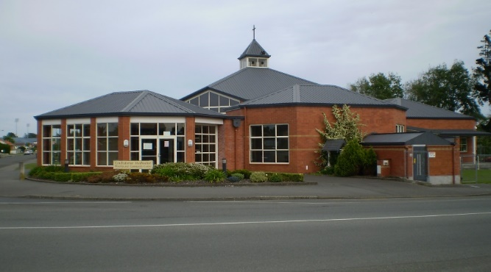

Sunday September 18th 2016

10.00am: Lindisfarne Service with Reverend Peter Taylor.

1.00pm: Tongan Service.
_________________________________

If you know of anyone who is in hospital, or has just come home from hospital, and would like someone to visit them, please inform the Reverend Peter or one of the Parish Stewards (Betty, Muriel or Eddie).

Prayer. (Ps 23:5) You serve me a six-course dinner right in front of my enemies. You revive my drooping head; my cup brims with blessing.
God, we so often don’t even see the blessings piling up right under our noses. Help us to see and to understand the fullness of them all, that fullness which is there to the greatest extent especially in the hour of our greatest need.
(from "The Message")

Lindisfarne Calendar
Sunday 18th September | 10.00am  1.00pm  3.00pm | Lindisfarne Service with Reverend Peter Taylor.  Tongan Service  Private Booking
Monday 19th | 3.30pm  5.30pm | Story Room.  Girl Guiding New Zealand..
Tuesday 20th | 10.00am  3.30pm  7.00pm | Property and Finance Committee.  Story Room.  Worship and Education Committee.
Wednesday 21st | 7.00pm  7.30pm | North Bowls.  Choir Practice.
Thursday 22nd | 10.00am  10.00am  1.30pm  7.00pm | Craft Circle.  Alzheimers Society.  Sit and Be Fit.  South City Choir Practice.
Friday 23rd | 6.00pm | Southland Competitions Society.
Sunday 25th September | 10.00am  1.00pm  1.00pm | Lindisfarne Service with Reverend Peter Taylor.  Tongan Service  Fijian Service.
.

Meals on Wheels Reminder

Drivers are reminded that it is our turn this coming week.

Meeting Reminder
Property and Finance Committee members are reminded that they have a meeting at 10.00am on Tuesday 20th.
"Historic Invercargill"

Bus Tour next Saturday September 24th, assembling in Lindisfarne car park at 1.50pm, and leaving at 2.00pm
$10 per person for a two hour bus trip around the historic areas and buildings of Invercargill.
David Flack, a member of our congregation, is an experienced driver and tour guide and will share his wealth of knowledge and experience as our tour leader.
There are still a few seats available and we would like
to fill up the bus.
Please tell Margaret today if you would like to go and haven't already booked. If necessary, you can pay her later.

Emergency Food Parcels (Brown Bags)

Thank you to the people who regularly bring non-perishable goods for our Brown Bags. We are also very happy to receive gifts of money so we can buy the perishable food – bread, milk, margarine, fresh fruit and vegetables etc.
Even just a small donation is great. If five people gave 20 cents each week, that would be enough for a loaf of bread for someone in need. Just drop your “widow’s mite” into the green frog in the basket in the foyer.

Friday Club.

Thanks to all our helpers last Friday whether with the food, (lasagne followed by good old bread-and-butter pudding), or with the children’s potato activities.

??????????
Why do we press the T.V. remote controller harder when we know the batteries are going flat?

ROSTER FOR SUNDAY DUTIES
Sunday | 18th September | 25th September | October 2nd |  | October 9th
DOOR AND  WELCOME | Noeline and Findlay Collie | Margaret Brass Mags Kelly | Chris McDonald  Tony Weston |  | Hilda Fife  Christine Frame
VAN DRIVER | Bryon King | Murray Gibbs | Eddie Bremer |  | Findlay Collie
FLOWERS | Raewyn Birss | Ita Safole | Beverley Robinson |  | Dorothy King
MORNING TEA | Neil and Daphne Salter | Keith and Carol McKenzie | Carolyn McDonald  Judith Day |  | Susanne Staples  Sharon Taylor
NOTICES | Muriel McCulloch | Betty Snell | Eddie Bremer | Muriel McCulloch
CRECHE | Susanne Staples | School Holidays | School Holidays |  | School Holidays
KIDS KLUB | Carol McKenzie | School Holidays | School Holidays |  | School Holidays

CENTRE DUTIES
WEEK OF | LAWNS | SECURITY
19th September - 25th September | Mike Mika | Murray Gibbs
26th September - 2nd October | Ian Findlay | Joe Wilson
3rd October - 9th October | Runi Safole | Runi Safole
10th October -16th October | Neil Salter | Daphne Salter

SOME INVERCARGILL PARISH KEY PERSONNEL
Minister Reverend Peter Taylor 216-0281
Parish Council Secretary Carolyn Weston
Parish Stewards | Betty Snell Eddie Bremer Muriel McCulloch
Parish Council Chairman Reverend Peter Taylor |  |  |  |  | Treasurer David Little
Parish Council-  Congregational Representatives  Bookings Phone Office 216-0281 |  |  |  | Margaret Brass  Mags Kelly
Prayer Chain Co-ordinators |  |  | Joan and Murray Farley.
Bulletin Editors |  | Peter Lankshear Margaret Brass

Affordables Shop Manager Carolyn 216-9676

