Bulletin
The Invercargill Parish of the
Methodist Church of New Zealand.
Te Hahi Weteriana o Aotearoa.
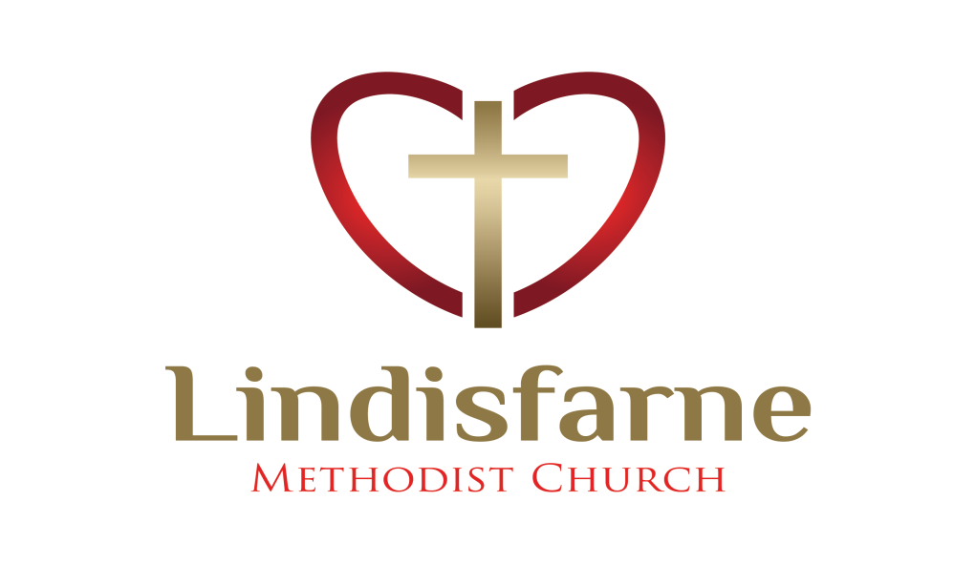
Lindisfarne Methodist Church, Worship and Community Centre.
Phone 216-0281.
e-mail: office@lindisfarne.org.nz Website: www.lindisfarne.org.nz

Sunday 9th September 2018.

10.00am:Lindisfarne Service with Nicol Macfarlane.

10.00am: Bluff Service with the Reverend Peter Taylor.

1.00pm: Tongan Service.

1.00pm: Fijian Service.

2.00pm: Peacehaven Service with Reverend Peter Taylor.

Prayer:
Heavenly Father, you've given us such a great promise - the promise of salvation. Father, forgive us when we sometimes put more hope in the things of this earth than in the incredible promises of your heaven.

Calendar
Sunday 9th  September | 10.00am  10.00am  1.00pm  1.00pm  2.00pm | Lindisfarne Service with Nicol Macfarlane.  Bluff Service with the Reverend Peter Taylor.  Tongan Service.  Fijian Service.  Peacehaven Service with Reverend Peter Taylor.
Monday 10th | 3.00pm  3.30pm  5.30pm | Kindergarten South  Story Room  Girl Guiding New Zealand.
Tuesday 11th | 8.00am  9.00am  3.30pm | Fostering Kids.  Stewards and Presbyter.  Story Room.
Wednesday 12th | 7.00pm  7.30pm | North Invercargill Bowls.  Choir Practice.
Thursday 13th | 10.00am  11.00am  1.30pm  7.00pm  7.00pm | Craft Circle.  Service at Cargill Home with Reverend Peter Taylor.  Sit and Be Fit.  Blues Bowling Club.  South City Choir Practice.
Saturday 15th | 11.30am | Private Booking.
Sunday 16th  September | 10.00am  1.00pm | Lindisfarne Spring Flower Service with the Reverend Peter Taylor.  Tongan Service.

As we did last year, we are taking up a retiring collection for the Interchurch Council for Hospital Chaplaincy, which ensures we have chaplaincy provision at our hospital.
You may make your contribution on Sundays 16th and 23rd September.

Pastoral Care If you know of someone who needs pastoral care, please let the stewards know. Their names are on the back of the Bulletin.
For Spring Flower service next Sunday you are asked to bring bunches of flowers to be brought forward during the service.

Knitters
Judith and Betty would like to thank all those who knitted scarves and beanies over the winter. All have been much appreciated. We have a request from MYPLC (My Place) for baby booties and beanies
If anyone can knit either of these, they will be much appreciated.

Mark these dates in your diary.

Saturday 6th October. A car trial with a difference. Open to everyone. If you don’t have a car, you will be invited to join others. We will start in the early afternoon and finish with a barbecue back at Lindisfarne. Each carload to provide a salad or a dessert.

Saturday 10th November. Our annual garage sale. Keep bringing in things for sale and re-usable bags for some purchases. We will also need helpers on Friday 9th November to set up, and on the Saturday as sales people. Talk to Daphne if you need more information.
___________________________________________________________

A Good Question
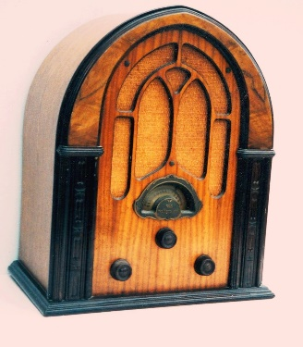
Recently I was asked why some old radios look like church windows!
In the early 1930's the Great Depression was stifling the World's economy, and people increasingly turned to radio as a diversion from their problems. But elaborate radio cabinets were expensive and in an effort to reduce costs the industry evolved an veneered arched laminated cabinet that was strong, used a minimum of material and yet was cheaply made. These affordable radios proved to be very popular and saved many makers from failure.
There was however another problem.
Radio was closely associated with the movie industry, judged by conservatives, with some justification, to be immoral. The arched cabinet again came to the rescue. As can be seen from the typical example in the picture, the front was often given some elements of Gothic cathedral architecture. It was a subtle move that subliminally reassured many buyers.
These radios became known as Cathedrals or Gothics. PML
ROSTER FOR SUNDAY DUTIES
Sunday | September 9th | September  16th |  | September  23rd | September  30th
DOOR AND  WELCOME | Ita and Runi Safole | Carol Chinpoy  Nicol Macfarlane |  | Margaret Brass  Dot Anderson | Glenys and Ian Findlay
VAN DRIVER | Findlay Collie | Bryon King |  | Sharon Taylor | Eddie Bremer
FLOWERS | Beverley Robinson |  | Dorothy King | Betty Snell | Mags Kelly
MORNING TEA | Judith Stevens  Sarah Jenkin | Carolyn Clearwater  Christine Frame |  | Beth Gibbs  Betty Snell | Verna Eason Beverly Service
NOTICES | Noeline Collie | Judith Stevens |  | Muriel McCulloch |  | Noeline Collie
CRECHE | Betty Snell | Beth Gibbs |  | Amanda Hare | School Holidays
KIDS KLUB | Neil Salter | Neil Salter |  | Carol McKenzie | Carol McKenzie

CENTRE DUTIES
WEEK OF | LAWNS | SECURITY
September 10th -September 16th | Ian Findlay | Margaret Brass
September 17th - September 23rd | Runi Safole | Runi Safole
September 24th - September 30th | Findlay Collie | Cam McCulloch
October 1st - October 7th | Chris McDonald | Hartley Hare

Some Invercargill Parish Key Personnel

Minister & Parish Council Chairman Reverend Peter Taylor 216 0281
Parish Council Secretary Carolyn Weston
Parish Stewards Noeline Collie, Muriel McCulloch, Judith Stevens
Treasurer David Little
Parish Council Congregational Representatives
Margaret Brass, Mags Kelly, Beverly Service
Bookings Phone Office 216 0281
Prayer Chain Co-ordinators Joan and Murray Farley
Bulletin Editors Peter Lankshear, Margaret Brass
Committee Convenors
Pastoral/Outreach - Raewyn Birss (Pastoral Care Team – Betty Snell)
Finance/Property – Cam McCulloch Worship/Education – Carol McKenzie

