|  |  |  |  |
| --- | --- | --- | --- |
| **ROSTER**  If you are unable to do your rostered duty, please arrange a swap or substitute and inform the Bulletin editors: Peter L. 217-5515, and Margaret 216-6175 or the office 216-0281 | | | |
| **SUNDAY DUTIES** | | | |
| **Sunday** | **October 23rd** | **October 30th** | **November 6th** |
| **Door** | Neil and Daphne | Christine and Barbara | Jessie and Betty |
| **Morning Tea** | Robyn and Chris P. | Bryon and Dorothy | Judith and Sarah |
| **Flowers** | Nicol | Ita | Jessie |
| **Minister’s Steward** | Barbara | Chris P. | Carolyn |
| **Prayer Book** | Nicol | Keith | Janice M. |
| **Bible Reading** | Evelyn | Chris McD. | Dorothy King |
| **Kids Club** | Sherilee | Sherilee | Sherilee |
| **Creche** | Labour Weekend | Betty | Carol |
| **Van Driver** | ------------ | ------------ | Daphne |
| **Communion** | ------------ | ----------- | Noeline and Evelyn |
| **Parish Lunch** | ------------ | ------------ | Carolyn and Evelyn |
|  | | | |
| **CENTRE DUTIES** | | | |
| **WEEK BEGINNING** | **October 24th** | **October 31st** | **November 7th** |
| **Lawns** | Neil | Findlay | Bryon |
| **Security** | Daphne | Hartley | Darren |



Musical Vespers

Thank you to everyone who attended Musical Vespers last Sunday.

Together we raised $415.00 for the Southland Charity Hospital 😊

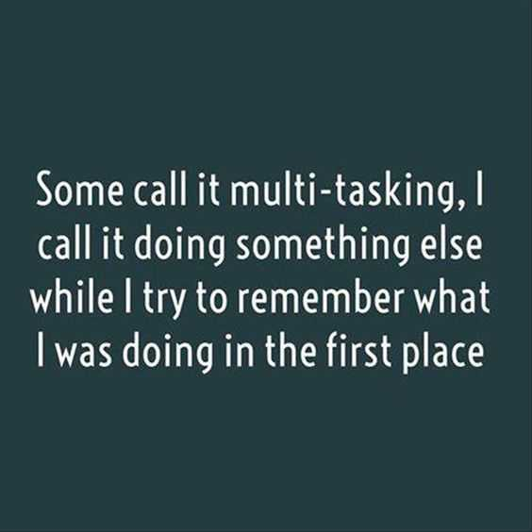.

**Lindisfarne**

**Methodist Church, Worship and**

**Community Centre.**

22 Lindisfarne Street, Invercargill 9812 . Phone 216-0281.

e-mail: [office@lindisfarne.org.nz](mailto:office@lindisfarne.org.nz)

Website: [www.lindisfarne.org.nz](http://www.lindisfarne.org.nz)

**Minister: Reverend Tania Shackleton**

[shackletont@gmail.com](mailto:shackletont@gmail.com) 217 0023/ 022 685 7688.

**23rd October Service 10.00am.**

**Worship Leader: Rev. Tania Shackleton.**

1.00pm: Tongan Service.

*Welcome to Worship, we are glad you are here.*

*Haere mai ki te koropiko, he koa ana m*ā*tou kua haere mai koutou ki konei.*

Happy celebrating to all those with birthdays and anniversaries this week!

|  |  |  |
| --- | --- | --- |
| **LINDISFARNE CALENDAR** | | |
| **Sunday 23rd**  **October** | 10.00am  1.00pm  1.00pm | Lindisfarne Service (live and Zoom),  Led by Rev. Tania Shackleton.  Tongan Service.  Fijian Service. |
| **Tuesday 25th** | 8.00am  10..30am  2.00pm  6.30pm  7.00pm | Assure Quality Training.  Prayer Hour.  Worship and Education Meeting. See notice below.  Windsor Brownies.  Parish Council Meeting. |
| **Wednesday 26th** | 8.00am  7.30pm | Assure Quality Training.  Choir Practice. |
| **Thursday 27th** | 8.00am  10.00am  1.30pm  7.00pm | Assure Quality Training.  Craft Circle  Sit and be Fit.  South City Choir Practice. |
| **Friday 28th** | 8.00am  11.00am | Assure Quality Training.  Thrive in Light – Yoga Class. |
| **Saturday 29th** | 8.00am | Assure Quality Training. |
| **Sunday 30th**  **October** | 10.00am  1.00pm | Lindisfarne Service (live and Zoom), Led by Rev. Tania Shackleton.  Tongan Service. |

Covid 19 is Back



[This Photo](https://blog.okfn.org/2020/04/16/coronavirus-why-an-open-future-has-never-been-more-important/) by Unknown Author is licensed under [CC BY](https://creativecommons.org/licenses/by/3.0/)

As we have Covid back in our church community

We would like to remind everyone that we have both masks and RAT tests available in the office.

Please help yourselves or ask Laura.

Worship and Education Meeting.

Worship and Education Committee Meeting will be held on Tuesday 25th October 2pm at Evelyn's Home

FUNDRAISING

At last week’s AGM the Finance Reports did not include fund raising by the Outreach Committee

Here is a summary

***Results from our fundraising events:***

***June/July 2021 Cheese Rolls $1571.33***

***October 2021 Cheese Rolls $527.60***

***March 2022 Kaye’s Bakery $155.90***

***May 2022 Soup $231.04***

***Not in this financial year***

***July 2022 Soup $323.65***

***July 2022 Garage Sale $1801.00***

Special Christmas parcels were distributed through “our” schools to 18 families in particular need.

***Costs for these were off-set by donations of $760.00, resulting in cost to the church of only $4.50.***

***We are very grateful to those of our congregation who make donations specifically for this work,***

-------------------------------------------------------

To Join our Zoom gathering  
<https://us02web.zoom.us/j/84444677835?pwd=SkhjbDVzbDAxZkhWcG5FaTR2Y3NPQT09>  
Meeting ID: 844 4467 7835

Passcode: 585033