Bulletin
The Invercargill Parish of the Methodist Church of New Zealand.
Te Hahi Weteriana o Aotearoa.
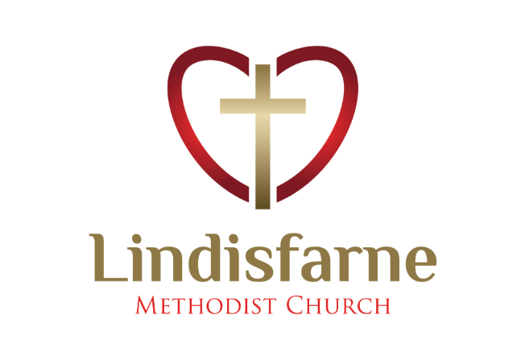
Lindisfarne Methodist Church, Worship and Community Centre.
Phone 216-0281.
e-mail: office@lindisfarne.org.nz Website: www.lindisfarne.org.nz
Lindisfarne Methodist Church

_______________________________________________________________

Sunday April 11th 2021.

10.00am: Lindisfarne Service led by the Reverend Peter Taylor.

10.00am: Riverton Service led by Nicol Macfarlane.

1.00pm: Tongan Service.

1.00pm: Fijian Service.

2.00pm: Service at Peacehaven

Prayer:
Lord, help us to pray for your strength as we walk with another, holding a hand, or walking behind, picking up the pieces for you to remould in Your likeness.

Calendar
Sunday 11th  April | 10.00am  10.00am  1.00pm  1.00pm  2.00pm | Lindisfarne Service led by the Reverend Peter Taylor.  Riverton Service led by Nicol Macfarlane.  Tongan Service.  Fijian Service.  Peacehaven Service led by the Reverend Peter Taylor.
Monday 12th | 9.00am  5.30pm | Oranga Tamariki.  Girl Guiding New Zealand.
Wednesday 14th | 7.00pm  7.30pm | North Invercargill Bowls.  Choir Practice.
Thursday 15th | 1.30pm  7.00pm  7.00pm | Sit and Be Fit.  Blues Bowls.  South City Choir Practice.
Friday 16th | 4.30pm  7.00pm | Friday Club.  Sri Lanken Society.
Saturday 17^{h} |  | Private Booking.
Sunday 18th  April | 10.00am  10.00am  1.00pm | Lindisfarne Service led by Nicol Macfarlane.  Bluff Service led by Neil Salter.  Tongan Service.

Farewell Verna

This week we have been saddened by the death of Verna Eason.

She is remembered as “a breath of fresh air’, larger than life character, storyteller, comedienne,
(who can forget those skits - giving the cat a pill, or buying a bathing suit, or indeed the chicken suit itself?)
Verna was a loyal member of Women’s Fellowship and our choir. She was a wonderful baker until illness put a stop to that.
Her great love for her family was obvious to us all.

Coming Events

Note these dates in your diary

Sunday 9th May -Mother’s Day Pancake breakfast from 9.15 am.

Saturday 12th June – Church Dinner.

Offering Receipts
If you used our envelope system for your offering all this year, your annual receipt for 2020-2021 is now available.
Remember that you can use this to claim a 30% tax rebate.
Ask Margaret if you need the IRD form to fill in.
Please use your new envelopes now, as numbers have changed.
Receipts are not yet available for people who pay directly to the bank. Ask Margaret if you need the IRD form to fill in.

~~~~~~~~~~~~~~~~~~~~~~~~

"In the end, it's not the years in your life that count.
It's the life in your years. "

ROSTER FOR SUNDAY DUTIES.
Sunday | April 11th | April 18th |  | April 25th | May 2nd
DOOR AND WELCOME | Betty Snell Daphne Salter | Evelyn and Neil Cruickshank | Barbara Richardson  Mags Kelly |  | Noeline and Findlay Collie
VAN | Ian Findlay | Bryon King |  | Daphne Salter | Sharon Taylor
MORNING TEA | TBA | Neil and Daphne Salter |  | Noeline and Findlay Collie | Raewyn Birss  Sarah Jenkin
FLOWERS | Nicol Macfarlane | Ita Safole |  | Raewyn Birss | Dorothy King
NOTICES | Sarah Jenkin | Carolyn McDonald |  | Evelyn Cruickshank |  | Sarah Jenkin
CRECHE | Amanda Hare | School Holidays |  | School Holidays | School Holidays
KIDS KLUB | Annette Little | School Holidays |  | School Holidays | School Holidays

CENTRE DUTIES
WEEK OF | LAWNS | SECURITY
April 12th – April 18th | Neil Salter | Hartley Hare
April 19th – April 25th | Findlay Collie | Daphne Salter
April 26th -May 2nd | Bryon King | Runi Safole
May 3rd – May 9th | Ian Findlay | Bryon King

Some Invercargill Parish Key Personnel

Presbyter & Parish Council Chairman Reverend Peter Taylor 216 0281
Parish Council Secretary Carolyn Weston
Parish Stewards Sarah Jenkin, Evelyn Cruickshank, Carolyn McDonald
Treasurer David Little
Parish Council Congregational Representatives
Margaret Brass, Mags Kelly, Darren Weston
Bookings Phone Office 216 0281
Prayer Chain Co-ordinator Mags Kelly
Bulletin Editors Peter Lankshear, Margaret Brass
Committee Convenors
Pastoral/Outreach – Noeline Collie (Pastoral Care Team – Betty Snell)
Finance/Property – Cam McCulloch (Health & Safety – Darren Weston)
Worship/Education – Neil Cruickshank

