Bulletin
The Invercargill Parish of the Methodist Church of New Zealand.
Te Hahi Weteriana o Aotearoa.
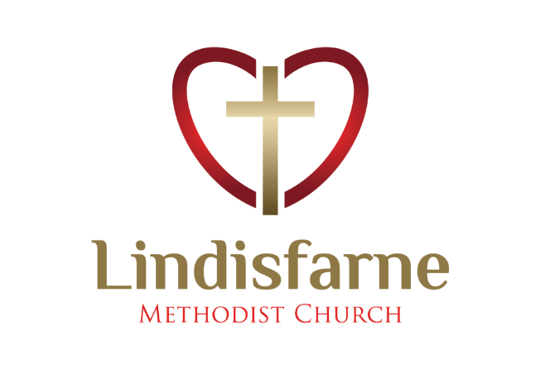
Lindisfarne Methodist Church, Worship and Community Centre.
Phone 216-0281.
e-mail: office@lindisfarne.org.nz Website: www.lindisfarne.org.nz
Lindisfarne Methodist Church

_______________________________________________________________

Sunday April 18th 2021.

10.00am: Lindisfarne Service led by Nicol Macfarlane

10.00am: Bluff Service led by Neil Salter.

1.00pm: Tongan Service.

Prayer:
Lord, as we stand in awe before your rainbow of hope, help us to claim it, share it with all around us, for them to further share.

Calendar
Sunday 18th  April | 10.00am  10.00am  1.00pm | Lindisfarne Service led by Nicol Macfarlane.  Bluff Service led by Neil Salter.  Tongan Service.
Wednesday 21st | 7.00pm | North Invercargill Bowls.
Thursday 22nd | 1.30pm  5.30pm  7.00pm | Sit and Be Fit.  Right Track Graduation.  Blues Bowls.
Saturday 24th | 6.00pm | Private Booking.
Sunday 25th  April | 10.00am  1.00pm  1.00pm | Lindisfarne Service led by the Reverend Peter Taylor.  Tongan Service.  Fijian Service.

Offering Receipts
If you don’t yet have your annual receipt for your offering, please collect it from the foyer.
Remember that you can claim back 33% from the tax department.
You could then donate your refund to us during this year, or just keep it for yourself.
This money belongs to you, not the church and not the tax department!

Duties Roster
For a few weeks there will be blank spaces in some of the rostered duties listed in the Bulletin.
If you could fill one of these spaces, please tell Margaret, or just simply do it!

~~~~~~~~~~~~~~~~~~~~~~~~~~~~~~~
“Yesterday I was clever, so I wanted to change the world.
Today I am wise, so I am changing myself.”

Knitting
Red Cross Representative Glenys Findlay spoke to the last Legs meeting about the need for refugees to have covers for hot water bottles.

Betty Snell hopes that with winter approaching some of our congregation might knit some covers for them. Collect pattern instructions from Betty.

The Knitting Group would appreciate receiving 4 ply wool (not acrylic) in bright colours to knit singlets for babies born at Kew Hospital, whose parents don’t realise how cold our winters can be.

The Group would also appreciate 8 ply wool or acrylic to knit cot and car seat blankets.

~~~~~~~~~~~~~~~~~~~~~~~~~~~~~~~~~~~~

Methodism
Where did the term Methodist come from? Whilst in Oxford in the 1730s John, his brother Charles, and like-minded friends were part of The Holy Club, a religious group emphasising methodical study and devotion.
Others in Oxford gave the group the nickname of Methodist because of this emphasis. They were also known for their frequent communion services and for fasting two days a week.
John Wesley 1703-1791 They added social services to their activities, visiting Oxford prisoners (teaching them to read, paying their debts, and trying to find employment for them), visiting workhouses and poor people, distributing food, clothes, medicine, books and even running a school.

ROSTER FOR SUNDAY DUTIES.
Sunday | April 18th | April 25th | May 2nd |  | May 9th
DOOR AND WELCOME | Evelyn and Neil Cruickshank | Barbara Richardson  Mags Kelly | Noeline and Findlay Collie |  | Chris McDonald  Tony Weston
VAN | Bryon King | Daphne Salter | Sharon Taylor |  | Ian Findlay
MORNING TEA | Neil and Daphne Salter | Noeline and Findlay Collie | Raewyn Birss  Sarah Jenkin |  | Keith and Carol McKenzie
FLOWERS | Ita Safole | Raewyn Birss | Dorothy King |  | Mags Kelly
NOTICES | Carolyn McDonald | Evelyn Cruickshank | Sarah Jenkin | Evelyn Cruickshank
CRECHE | School Holidays | School Holidays | School Holidays
KIDS KLUB | School Holidays | School Holidays | School Holidays |  | Lynley Dean

CENTRE DUTIES
WEEK OF | LAWNS | SECURITY
April 19th – April 25th | Findlay Collie | Daphne Salter
April 26th -May 2nd | Bryon King | Runi Safole
May 3rd – May 9th | Ian Findlay | Bryon King
May 10th – May 16th | Nicol Macfarlane | Eddie Bremer

Some Invercargill Parish Key Personnel

Presbyter & Parish Council Chairman Reverend Peter Taylor 216 0281
Parish Council Secretary Carolyn Weston
Parish Stewards Sarah Jenkin, Evelyn Cruickshank, Carolyn McDonald
Treasurer David Little
Parish Council Congregational Representatives
Margaret Brass, Mags Kelly, Darren Weston
Bookings Phone Office 216 0281
Prayer Chain Co-ordinator Mags Kelly
Bulletin Editors Peter Lankshear, Margaret Brass
Committee Convenors
Pastoral/Outreach – Noeline Collie (Pastoral Care Team – Betty Snell)
Finance/Property – Cam McCulloch (Health & Safety – Darren Weston)
Worship/Education – Neil Cruickshank

