Bulletin
The Invercargill Parish of the Methodist Church of New Zealand.
Te Hahi Weteriana o Aotearoa.
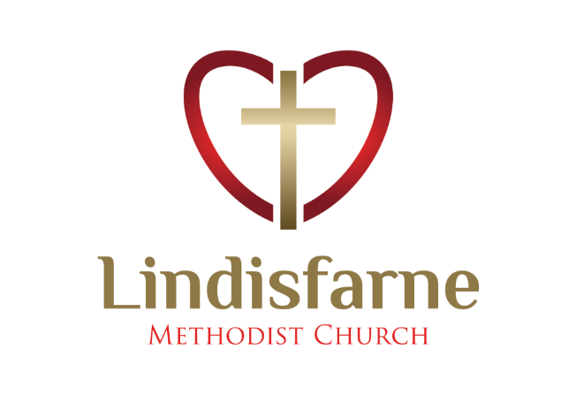
Lindisfarne Methodist Church, Worship and Community Centre.
22 Lindisfarne Street. Invercargill 9812 Phone 216-0281.
e-mail: office@lindisfarne.org.nz Website: www.lindisfarne.org.nz
Lindisfarne Methodist Church.

Sunday August 15th 2021.

10.00am: Lindisfarne Service led by Nicol Macfarlane.

10.00am: Bluff Service led by the Reverend
Peter Taylor.

1.00pm: Tongan Service.

Meditation Zephaniah 2 v3
Seek the Lord, all you humble of the land; you who do what he commands. Seek righteousness, seek humility.
Perhaps you will be sheltered on a day of the Lord’s anger.

Calendar
Sunday  August 15th | 10.00am  10.00am  1.00pm  4.00pm | Lindisfarne Service led by Nicol Macfarlane.  Bluff Service led by the Reverend Peter Taylor.  Tongan Service.  Private Booking.
Monday 16th | 5.30pm | Girl Guiding NZ.
Tuesday 17th | 12.30pm  2.00pm | Oranga Tamariki  Study Group.
Wednesday 18th | 6.30pm  7.00pm  7.30pm | Bread Tags Meeting. (See below).  North Invercargill Bowls.  Choir Practice.
Thursday 19th | 11.30am  1.30pm  7.00pm | Mid-Week Service.  Sit and Be Fit.  South City Choir Practice.
Friday 20th | 4.30pm | Friday Club.
Saturday 21st | 10.00am | Private Booking.
Sunday  August 22nd | 10.00am  1.00pm  1.00pm | Lindisfarne Service led by the Reverend Peter Taylor.  Tongan Service.  Fijian Service.

Bread Tags
Have you been wondering why we are collecting these? On Wednesday 18th August at 6.30 pm representatives from the Georgetown Scout Group will be in our foyer to show and tell us.

Duties Roster
Work is well under way on the new roster, but … we really need more people to help with morning tea, monthly lunch, creche and driving the van. Please tell Margaret what you will do. The more people involved, the fewer turns each has.

Cheese Rolls
We will be making a limited number of cheese rolls on Thursday 26th August at 1.30 pm. Order forms are in the foyer. Last day for orders is next Sunday 22nd August.
We will need helpers to make the cheese rolls, so please mark the date and time in your diary.

A Service to Remember
Many of us may recall a church service that had great personal significance or perhaps was very moving. Thirty years ago, my late wife Iris and I experienced one such that has left lasting memories.
We were members of a mostly American group touring Russia. On a Sunday morning we were in the city of Smolensk, about 350km west of Moscow and our tour guide suggested visiting the Cathedral. We should be there around the time the choir would be singing.
Eastern Orthodox Church services and buildings are significantly different from those of the Western Church. Buildings are often brightly coloured - almost flamboyant. Smolensk Cathedral exterior is blue and white with lavish use of gold leaf enhancing the “onion” domes as well as the stunning interior. Russian churches are famous for their icons and painted Biblical scenes and Smolensk Cathedral has its share.
When we arrived, the service was in progress. There were few men, but this was to be expected as so many did not survive The Great Patriotic War (WWII). Many differences from Western worship were immediately apparent. There appeared to be no seating for the congregation who stood on the highly polished stone floor. Most of the service was conducted by a priest chanting in a pleasant resonant voice. At no time whilst we were there was there any general hymn singing.
Instead, the choir sang. They were high up, out of sight, and their sound flooded the cathedral. There was no organ accompaniment. They did not need any. The overused term heavenly voices came to mind, a full-bodied sound from high registering sopranos to impossibly deep bass voices. Several members of our group were seen surreptitiously wiping a tear, the singing was so moving. Peter L.
(As small Bulletin pictures in black and white cannot do justice to the splendour of the cathedral, two larger coloured photos have been put on the foyer noticeboard.)

ROSTER FOR SUNDAY DUTIES.
Sunday | August 15th |  |  | August 22nd | August 29th |  |  |  | September 5th
DOOR AND WELCOME | Mags Kelly  Dot Anderson |  |  | Carolyn and  Chris McDonald | Margaret Brass  Barbara Richardson |  |  |  |  | Raewyn Birss  Tony Weston
VAN | Ian Findlay |  |  | Daphne Salter | Bryon King |  |  |  | Ian Findlay
MORNING TEA | Sharon Taylor  Sarah Jenkin |  |  | Keith and Carol McKenzie | Neil and Daphne Salter |  |  |  | Annette and David Little
FLOWERS | Raewyn Birss |  |  | Dorothy King | Mags Kelly |  |  |  | Dot Anderson
NOTICES | Sarah Jenkin |  | Evelyn Cruickshank |  |  | Sarah Jenkin |  | Carolyn McDonald
CRECHE | Carol McKenzie |  |  | Petra Weston | Sharon Taylor |  |  |  | Amanda Hare
KIDS KLUB | Carla Werder | Hartley and Amanda Hare |  |  |  |  | Raewyn Birss |  | Neil Salter

CENTRE DUTIES
WEEK OF | LAWNS | SECURITY
August 16th - August 22nd | Ian Findlay | Hartley Hare
August 23rd – August 29th | Bryon King | Daphne Salter
August 30th – September 5th | Nicol Macfarlane | Margaret Brass
September 6th – September 12th | Lester Dean | Bryon King

Some Invercargill Parish Key Personnel

Presbyter & Parish Council Chairman Reverend Peter Taylor 216 0281
Parish Council Secretary Carolyn Weston
Parish Stewards Sarah Jenkin, Evelyn Cruickshank, Carolyn McDonald
Treasurer David Little
Parish Council Congregational Representatives
Margaret Brass, Mags Kelly, Darren Weston
Bookings Phone Office 216 0281
Prayer Chain Co-ordinator Mags Kelly
Bulletin Editors Peter Lankshear, Margaret Brass
Committee Convenors
Pastoral/Outreach – Noeline Collie (Pastoral Care Team – Betty Snell)
Finance/Property – Cam McCulloch (Health & Safety – Darren Weston)
Worship/Education – Neil Cruickshank

