Bulletin
The Invercargill Parish of the Methodist Church of New Zealand.
Te Hahi Weteriana o Aotearoa.
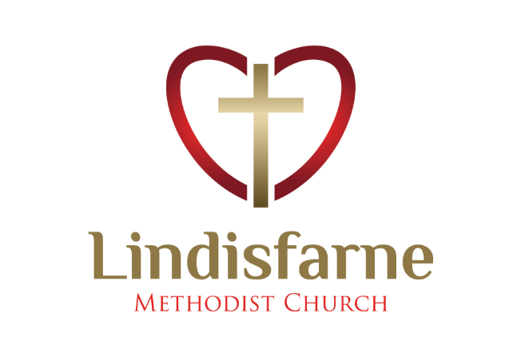
Lindisfarne Methodist Church, Worship and Community Centre.
Phone 216-0281.
e-mail: office@lindisfarne.org.nz Website: www.lindisfarne.org.nz

Lindisfarne Methodist Church

_______________________________________________________________

Sunday March 28th 2021.
Palm Sunday and Harvest Thanksgiving.

10.00am: Lindisfarne Service led by the Reverend Peter Taylor.

1.00pm: Tongan Service.
1.00pm: Fijian Service.

Prayer:
As we celebrate this Passion Sunday, may we prepare ourselves for Good Friday and Easter Day, so that we may be encouraged in faith to remember how central they are to our faith.

Calendar
Sunday 28th  March | 10.00am  1.00pm  1.00pm | Lindisfarne Palm Sunday and Harvest Thanksgiving Service led by the Reverend Peter Taylor.  Tongan Service.  Fijian Service
Monday 29th | 5.30pm  7.30pm | Girl Guiding New Zealand.  Nicol’s Lent Study Group at Kings’ 44 George Street.
Wednesday 31st March | 11.15am  7.00pm  7.30pm | St John’s Girls’ School Choir.  North Invercargill Bowls.  Choir Practice.
Thursday  1st April | 1.30pm  2.00pm  7.30pm | Sit and Be Fit.  Lindisfarne Fellowship Group. (See notice opposite).  Maundy Thursday Service led the Reverend Peter Taylor.
Friday 2nd | 9.30am  1.00pm  3.00pm | Good Friday Service led by the Reverend Peter Taylor.  Tongan Service.  Set up for Wedding
Saturday 3rd |  | Private Booking.
Sunday 4th  April | 10.00am  1.00pm | Lindisfarne Communion Service led by the Reverend Peter Taylor. Parish Lunch to follow.  Tongan Service.

Offering Envelopes
Please pick up your offering envelopes for the next financial year from the foyer.
Start using them from next week.
As all numbers have been changed, you should not use old envelopes.

Last Week’s Safety Quiz Answer:

Our evacuation point is the Miller Street footpath, west of our carpark entrance.

Concert this Afternoon

Commencing at 2.30 this afternoon
This Photo by Unknown Author is licensed under CC BY-SA
in First Church, Tay Street,
A Capella Singers will present

Reflections on Easter,

Music by Palestrina, Haydn, Pergolesi, Stainer.

Readings by Reverend Peter Taylor,
Musical Director Christine McLeod.

Admission: Adults $20, Senior Citizens $15, Students $10, Children Free.
Holy Week Services

Wednesday 31st March 11.15am St John’s Girls’ School Choir share their Easter service.

Thursday 1st April 7.30pm Maundy Thursday Tenebrae Service.

Friday 2nd April 9.30am Good Friday Service.

Sunday 4th April 10.00am Easter Communion Service.

Lindisfarne Fellowship Group

Everyone is welcome to attend the Women’s Fellowship Group which will meet in the lounge at 2.00pm next Thursday April 1st.

The Hostess will be Mags.
The Reverend Peter Taylor will be the guest speaker.
If transport is required, please phone Betty.

ROSTER FOR SUNDAY DUTIES.
Sunday |  | March 28th | April 4th | April 11th |  | April 18th
DOOR AND WELCOME |  | Dot Anderson  Margaret Brass | Keith and Carol McKenzie | Betty Snell Daphne Salter |  | Evelyn and Neil Cruickshank
VAN |  | Ian Findlay | Sharon Taylor | Eddie Bremer |  | Bryon King
MORNING TEA |  | Nicol Macfarlane  Beverly Service | Carol McKenzie  Carolyn McDonald | Bryon and Dorothy King |  | Neil and Daphne Salter
FLOWERS |  | Betty Snell | Jessie Campbell | Nicol Macfarlane |  | Ita Safole
NOTICES | Evelyn Cruickshank |  | Carolyn McDonald. | Sarah Jenkin | Evelyn Cruickshank.
CRECHE |  | Amanda Hare | Easter | Carol McKenzie |  | School Holidays
KIDS KLUB |  | Annette Little | Easter | Annette Little |  | School Holidays

DUTIES NEXT SUNDAY
COMMUNION: Raewyn Birss, Neil Salter | LUNCH: Ita and Runi Safole

CENTRE DUTIES
WEEK OF | LAWNS | SECURITY
March 29th – April 4th | Runi Safole | Margaret Brass
April 5th – April 11th | Chris McDonald | Tony Weston
April 12th – April 18th | Neil Salter | Hartley Hare
April 19th – April 25th | Findlay Collie | Daphne Salter

Some Invercargill Parish Key Personnel

Presbyter & Parish Council Chairman Reverend Peter Taylor 216 0281
Parish Council Secretary Carolyn Weston
Parish Stewards Sarah Jenkin, Evelyn Cruickshank, Carolyn McDonald
Treasurer David Little
Parish Council Congregational Representatives
Margaret Brass, Mags Kelly, Darren Weston
Bookings Phone Office 216 0281
Prayer Chain Co-ordinator Mags Kelly
Bulletin Editors Peter Lankshear, Margaret Brass
Committee Convenors
Pastoral/Outreach – Noeline Collie (Pastoral Care Team – Betty Snell)
Finance/Property – Cam McCulloch (Health & Safety – Darren Weston)
Worship/Education – Neil Cruickshank

