Bulletin
The Invercargill Parish of the Methodist Church of New Zealand.
Te Hahi Weteriana o Aotearoa.
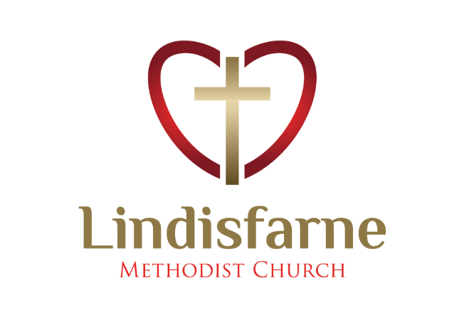
Lindisfarne Methodist Church, Worship and Community Centre.
22 Lindisfarne Street. Invercargill 9812 Phone 216-0281.
e-mail: office@lindisfarne.org.nz Website: www.lindisfarne.org.nz

Lindisfarne Methodist Church

Sunday May 16th 2021.

10.00am: Lindisfarne Service led by Neil Salter.

10.00am: Bluff Service led by the Reverend Peter Taylor.

1.00pm: Tongan Service.

Prayer:
We bless you, Lord, that we are made in your image yet gifted with differences in so many ways.
May we serve you gladly with our time and talents.

Calendar
Sunday 16th May | 10.00am  10.00am  1.00pm  1.00pm | Lindisfarne Service led by Neil Salter.  Bluff Service led by the Reverend Peter Taylor.  Private Booking.  Tongan Service.
Monday 17th | 5.30pm | Girl Guiding N.Z.
Tuesday 18th | 11.00am  4.00pm  5.00pm | Oranga Tamariki.  Worship and Education Committee.  Finance and Property Committee.
Wednesday 19th | 7.00pm  7.30pm | North Invercargill Indoor Bowls.  Choir Practice.
Thursday 20th | 10.00am  1.30pm  7.00pm | Pastoral Care Team.  Sit and Be Fit.  Blues Bowls.
Friday 21st | 4.30pm | Friday Club.
Saturday 22nd | 1.00pm  5.00pm | Private Booking.  Private Booking.
Sunday 23rd May | 10.00am  1.00pm  1.00pm | Lindisfarne Service led by the Reverend Peter Taylor.  Tongan Service.  Fijian Service.

Synonyms
English has developed over the course of about 1400 years to become the World’s leading international language. It has an enormous number of words with many having similar but not necessarily identical meanings.
For example, the word natural has no fewer than 70 alternatives or
synonyms.
Synonyms however, can have subtle differences meaning which may create problems.
For example, sight and vision are normally interchangeable and it is fine to say a smartly dressed woman is a vision.
Do not however say she is a sight!
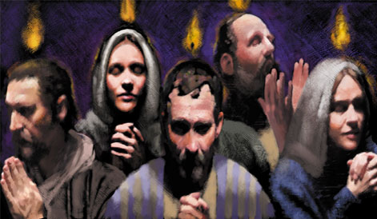

Pentecost
Next Sunday (23rd May) is Pentecost when the Holy Spirit was given.
(see Acts 2:1-13).
As you can see, the Easter display board has been removed, and it would be great if the Pentecost event could be displayed in its place.
Being creative is not a ‘closed shop’…here is your chance to have a go.
Any volunteers?

Brown Bags
There is a continuing demand for our emergency food parcels from various aid agencies.
Thank you to everyone who brings food items or money for them.
At present our supply of 420gm cans of items such as spaghetti, baked beans, fruit, soup and vegetables (green peas, corn or tomatoes only) is low.
Please keep to basic items, nothing that requires an addition e.g. cans of
“Just Add…..” If you are uncertain what to buy, just feed the pig in the foyer.
We would also like more of the plastic scoops that come with soap powder.

June 12th Midwinter Dinner
Adults $20 Children (with an adult) free.
Sign the list in the foyer by Sunday 6th June.

And in July we will be making our famous cheese rolls.

ROSTER FOR SUNDAY DUTIES.
Sunday | May 16th | May 23rd | May 30th | June 6th
DOOR AND WELCOME | Cam McCulloch  Jessie Campbell | Bryon King | Judith Stevens  Christine Frame | Dot Anderson  Raewyn Birss
VAN | Findlay Collie | Eddie Bremer | Bryon King | Daphne Salter
MORNING TEA | Raewyn Birss Christine Frame | Carolyn McDonald  Judith Day | Sarah Jenkin  Betty Snell | Beverly Service  Jo Templeton
FLOWERS | Dot Anderson | Betty Snell | Jessie Campbell | Nicol Macfarlane
NOTICES | Sarah Jenkin | Carolyn McDonald | Sarah Jenkin | Carolyn McDonald
CRECHE | Betty Snell | Petra Weston | Carol McKenzie | Queens Birthday
KIDS KLUB | Carol McKenzie | Carol McKenzie | Raewyn Birss | Queens Birthday

CENTRE DUTIES
WEEK OF | LAWNS | SECURITY
May 17th – May 23rd | Lester Dean | Cam McCulloch
May 24th – May 30th | Runi Safole | Margaret Brass
May 31st – June 6th | Chris McDonald | Darren Weston
June 7th – June 13th | Findlay Collie | Darren Weston

Some Invercargill Parish Key Personnel

Presbyter & Parish Council Chairman Reverend Peter Taylor 216 0281
Parish Council Secretary Carolyn Weston
Parish Stewards Sarah Jenkin, Evelyn Cruickshank, Carolyn McDonald
Treasurer David Little
Parish Council Congregational Representatives
Margaret Brass, Mags Kelly, Darren Weston
Bookings Phone Office 216 0281
Prayer Chain Co-ordinator Mags Kelly
Bulletin Editors Peter Lankshear, Margaret Brass
Committee Convenors
Pastoral/Outreach – Noeline Collie (Pastoral Care Team – Betty Snell)
Finance/Property – Cam McCulloch (Health & Safety – Darren Weston)
Worship/Education – Neil Cruickshank

