Bulletin
The Invercargill Parish of the Methodist Church of New Zealand.
Te Hahi Weteriana o Aotearoa.
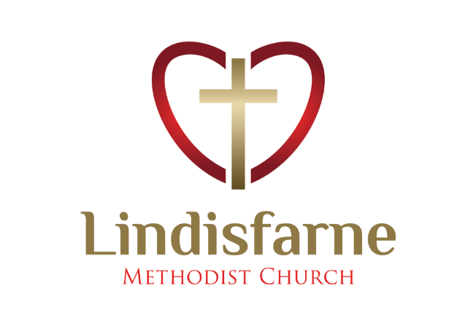
Lindisfarne Methodist Church, Worship and Community Centre.
22 Lindisfarne Street. Invercargill 9812 Phone 216-0281.
e-mail: office@lindisfarne.org.nz Website: www.lindisfarne.org.nz
Lindisfarne Methodist Church.

Sunday November 14th 2021.

10.00am: Lindisfarne Service led by Reverend Peter Taylor.

Prayer:
Lord, today and every day we give thanks for your unconditional love.
May we wrap love around those in our Parish who have been bereaved. Their loss is real, but love conquers all.
As you have taught us, love God, love others, love ourselves.

Calendar
Sunday  November 14th | 10.00am  1.00pm | Lindisfarne Service with Reverend Peter Taylor.  Fijian Service.
Monday 15th | 1.00pm  2.00pm  5.30pm | Stroke Club  Affordables Afternoon Tea at the Cheeky Llama.  Girl Guiding New Zealand.
Tuesday 16th | 5.00pm  5.30pm  7.00pm | Set up for Wednesday.  Finance and Property Committee.  Worship and Education Committee.
Wednesday 17th | 6.00pm  7.30pm | Private Booking.  Choir Practice.
Thursday 18th | 1.30pm  2.00pm  7.00pm | Sit and Be Fit.  Pastoral and Outreach Committee.  South City Choir Practice.
Friday 19th | 9.00pm | Oranga Tamariki.
Saturday 20th | 8.30am  4.00pm | Poihakena Portraits.  Private Booking.
Sunday 21st | 10.00am  10.00am | Lindisfarne Service with Reverend Peter Taylor.  Bluff Service led by Neil Salter.
Please note that there will be no Tongan Group services until Delta Alert Level 1 is in operation.

Some Sum
Computers do all their calculations using binary arithmetic which has only two units, 0 and 1
In binary 111,111,111 X 111,111,111 equals 12,345,678,987,654,321.
Christmas Food Parcels
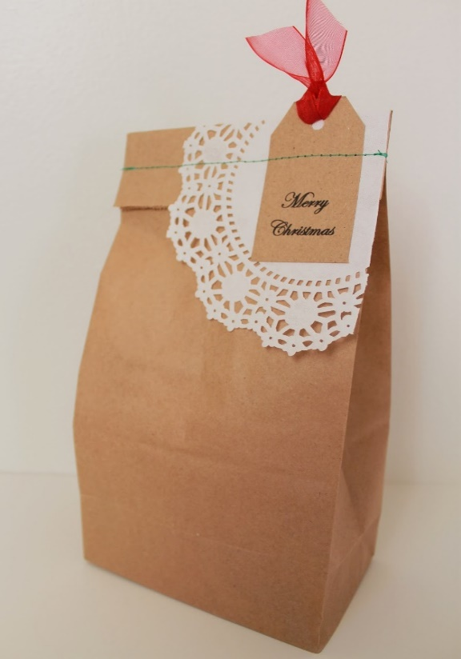

Yes! It’s time to think about these already.
As usual we would like to offer special Christmas “Brown Bags” to needy families at “our” schools.

Extra donations of tinned fruit, jellies, lollies, biscuits, Christmas pudding, Christmas cake, drinks, would be very welcome over the next two Sundays.

No toys or presents, please, but cash can certainly be used.
Margaret will be happy to write you a receipt.

Trivia
One outcome of the Covid restrictions is the lack of notices of activities, meetings etc that normally fill much of this page of the Bulletin.
Until we are back to normal there well may be trivial items to fill the otherwise empty space. Today we have some examples.,

America’s Pentagon Building has twice as many bathrooms as is necessary. When it was built in the 1940’s segregation laws required separate toilet facilities for blacks and whites.

When you travel across the Soviet Union you cross seven time zones.

Captain Cook was the first man to set foot in every continent except Antarctica.
ROSTER FOR SUNDAY DUTIES.
Sunday | November 14th | November 21st | November 28th | December 5th
DOOR | Margaret Brass  Mags Kelly | Neil and Daphne Salter | Christine Frame Barbara Richardson | Jessie Campbell  Betty Snell
VAN |  | Sharon Taylor | Ian Findlay | Sharon Taylor
MORNING TEA | No morning tea in Delta Level 2  Check the blue roster for upcoming duties
FLOWERS | Raewyn Birss | Nicol Macfarlane | Ita Safole | Jessie Campbell
NOTICES | Evelyn | Barbara | Carolyn | Evelyn
CRECHE | Amanda Hare | Petra Weston | Amanda Hare
KIDS KLUB | Amanda and Hartley Hare | Carla Werder | Christmas Breakup

CENTRE DUTIES
WEEK OF | LAWNS | SECURITY
November 15th – November 21st | Chris McDonald | Tony Weston
November 22nd -November 28th | Neil Salter | Runi Safole
November 29th – December 5th | Findlay Collie | Margaret Brass
December 6th -December 12th | Bryon King | Tony Weston

Some Invercargill Parish Key Personnel

Presbyter & Parish Council Chairman Reverend Peter Taylor 216 0281
Parish Council Secretary Carolyn Weston
Parish Stewards Evelyn Cruickshank, Carolyn McDonald, Barbara Richardson
Treasurer David Little
Parish Council Congregational Representatives
Margaret Brass, Mags Kelly, Sarah Jenkin, Nicol Macfarlane
Bookings Phone Office 216 0281
Prayer Chain Co-ordinator Mags Kelly
Bulletin Editors Peter Lankshear, Margaret Brass
Committee Convenors
Pastoral/Outreach – Noeline Collie (Pastoral Care Team – Betty Snell)
Finance/Property – Cam McCulloch Health & Safety – Darren Weston
Worship/Education –

