Bulletin
The Invercargill Parish of the Methodist Church of New Zealand.
Te Hahi Weteriana o Aotearoa.
Lindisfarne Methodist Church, Worship and Community Centre.
22 Lindisfarne Street. Invercargill 9812 Phone 216-0281.
e-mail: office@lindisfarne.org.nz Website: www.lindisfarne.org.nz
Lindisfarne Methodist Church.

Sunday November 21st 2021.

10.00am: Lindisfarne Service led by Reverend Peter Taylor.

10.00am: Bluff Service led by Neil Salter.

Prayer:
Heavenly Father, as we begin our summer months, we can reflect on the beauty and wonder at the intricate perfection of the plant world.
From the dormant winter months comes forth fresh growth, colour and perfume.
With it comes refreshed feelings of hope and thanks for the world you have created.
Thanks be to you, Lord.
Calendar
Sunday  November 21st | 10.00am  10.00am | Lindisfarne Service with Reverend Peter Taylor.  Bluff Service led by Neil Salter.
Monday 22nd | 5.30pm | Girl Guiding New Zealand.
Tuesday 23rd | 2.00pm  7.00pm | Off Site. Preachers and Worship Committees.  Leaders Meeting.  Parish Council Meeting
Wednesday 24th | 7.30pm | Choir Practice.
Thursday 25th | 10.00am  1.30pm  7.00pm | Craft Circle.  Sit and Be Fit.  South City Choir Practice.
Saturday 27th | 9.00am  6.30pm | Synod Meeting.  Private Booking.
Sunday 28th | 10.00am  1.00pm | Lindisfarne Service with Reverend Peter Taylor.  (Kids Klub breakup).  Fijian Service.
Please note that there will be no Tongan Group services until Delta Alert Level 1 is in operation.

The first computer bug was found by Grace Hopper, in an early naval computer. A moth was caught in some switch contacts and was causing errors. Grace’s entry in the computer’s logbook, referred to finding a “bug” and the term has stayed with computers ever since. Grace was a pioneering computer scientist and held the rank of rear admiral.

Christmas Food Parcels

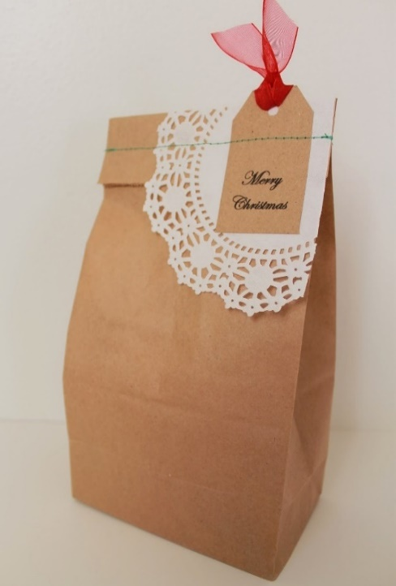
Yes! It’s time to think about these already.

As usual we would like to offer special Christmas “Brown Bags” to needy families at “our” schools.

Extra donations of tinned fruit, jellies, lollies, biscuits, Christmas pudding, Christmas cake, drinks, would be very welcome next Sunday. This is an urgent request because the parcels have to be packed and delivered in the first week of December before the schools close.

No toys or presents, please, but cash can certainly be used.
Margaret will be happy to write you a receipt.

From the Outreach meeting

The Outreach Committee has a small amount of grated cheese (frozen) left from cheese roll making.
Packets of 500 grams will be available for sale next Sunday for $6 each.
Cash in a named envelope, please.

ROSTER FOR SUNDAY DUTIES.
Sunday | November 21st | November 28th | December 5th | December 12th
DOOR | Neil and Daphne Salter | Christine Frame Barbara Richardson | Jessie Campbell  Betty Snell | Dot Anderson  Judith Stevens
VAN | Sharon Taylor | Ian Findlay | Sharon Taylor | Daphne Salter
MORNING TEA | No morning tea in Delta Level 2  Check the blue roster for upcoming duties
FLOWERS | Nicol Macfarlane | Ita Safole | Jessie Campbell | Betty Snell
NOTICES | Barbara | Carolyn | Evelyn | Barbara
CRECHE | Petra Weston | Amanda Hare |  | Betty Snell
KIDS KLUB | Carla Werder | Christmas Breakup

CENTRE DUTIES
WEEK OF | LAWNS | SECURITY
November 22nd -November 28th | Neil Salter | Runi Safole
November 29th – December 5th | Findlay Collie | Margaret Brass
December 6th -December 12th | Bryon King | Tony Weston
December 13th -December 19th | Nicol Macfarlane | Darren Weston

Some Invercargill Parish Key Personnel

Presbyter & Parish Council Chairman Reverend Peter Taylor 216 0281
Parish Council Secretary Carolyn Weston
Parish Stewards Evelyn Cruickshank, Carolyn McDonald, Barbara Richardson
Treasurer David Little
Parish Council Congregational Representatives
Margaret Brass, Mags Kelly, Sarah Jenkin, Nicol Macfarlane
Bookings Phone Office 216 0281
Prayer Chain Co-ordinator Mags Kelly
Bulletin Editors Peter Lankshear, Margaret Brass
Committee Convenors
Pastoral/Outreach – Noeline Collie (Pastoral Care Team – Betty Snell)
Finance/Property – Cam McCulloch Health & Safety – Darren Weston
Worship/Education –

