Bulletin
The Invercargill Parish of the Methodist Church of New Zealand.
Te Hahi Weteriana o Aotearoa.
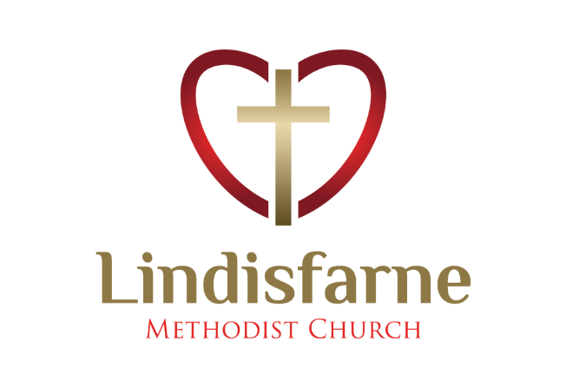
Lindisfarne Methodist Church, Worship and Community Centre.
22 Lindisfarne Street. Invercargill 9812 Phone 216-0281.
e-mail: office@lindisfarne.org.nz Website: www.lindisfarne.org.nz
Lindisfarne Methodist Church.

Sunday October 10th 2021.

10.00am: Lindisfarne Service led by Reverend Peter Taylor.

1.00pm: Fijian Service.

Prayer:
“Everything is possible for God.” Mark 10:27.
We bless you dear Lord for bringing us together: even in different ways in different times. The bonds of your love and power of your spirit make things possible which once we might have doubted.
Thank you for your grace.

Calendar
Sunday  October 10th | 10.00am  1.00pm | Lindisfarne Service with Reverend Peter Taylor.  Fijian Service,
Monday 11th | 9.30am | Oranga Tamariki.
Tuesday 12th | 8.30am | Oranga Tamariki.
Thursday 14th | 10.00am  11.00am  1.30pm | Craft/Knitting Circle.  Cargill Home Service with the Reverend Peter Taylor  Sit and be Fit.
Friday 15th | ?  4.30pm | Parish Council.  Private Booking.
Saturday 16th | 2.00pm  4.00pm  5.00pm | Face to Face Meeting (see notice opposite).  Private Booking.  Private Booking.
Sunday  October 17th | 10.00am  10.00am  1.00pm  6.00pm | Lindisfarne Service with Reverend Peter Taylor. Service includes Congregational AGM.  Bluff Service led by Neil Salter.  Tongan Service?  Private Booking.

Church Van
For many years we have brought people to our Sunday service in our van. Unfortunately, we may have to reduce the number of times this can happen, because we do not have enough drivers. Please think hard about whether you could help. Tell Peter or Noeline.

Cheese rolls
Thank you to the people who came to make our latest batch of cheese rolls on Wednesday.
If you ordered cheese rolls for July, please collect yours (frozen) after today’s service. There are a few more for sale – mostly brown – at the regular price of $8 a dozen or $30 for four dozen.
IOUs are acceptable.

Face to Face Meeting
Our proposed new presbyter Tania Shackleton will be visiting Invercargill next weekend (Covid permitting). All members of the congregation are invited to meet with her at 2pm on Saturday at Lindisfarne centre, to join in the decision-making about whether we would like her as our new presbyter. Tania has been in ministry with the Methodist church since 2013, and is currently presbyter at Tawa Union Church.

AGM Agenda. Our Annual General Meeting will be held as part of next Sunday’s service. The agenda is now available, one per family, please.
Lockdown Morning Tea
During our recent Lockdown 3 our ever- resourceful Minister Peter organised Sunday morning tea and chats using a computer programme called “Zoom”
Participants are in their homes and their thumbnail images are seen across a computer screen. Voices come from the computer loudspeaker.
Whoever is speaking at the time appears centre screen
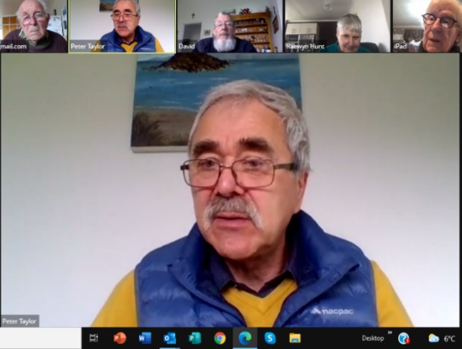
And no … you brew your own tea!

ROSTER FOR SUNDAY DUTIES.
Sunday |  | October 10th | October 17th |  | October 24th | October 31st
DOOR |  | Ita and Runi Safole | Evelyn and Neil Cruickshank |  | Muriel and Cam McCulloch | Raewyn Birss  Dot Anderson
VAN |  | Ian Findlay | Sharon Taylor |  |  | Bryon King
MORNING TEA |  |  | Sarah and Jo ?? |  | Beverly S. and  Christine ?? | Ita and Runi  Safole??
FLOWERS |  | Raewyn Birss | Dorothy King |  | Mags Kelly | Dot Anderson
NOTICES | Evelyn Cruickshank |  | Carolyn McDonald | Evelyn Cruickshank |  |  | TBA
CRECHE |  | School Holidays | School Holidays | Labour Weekend |  | Betty Snell
KIDS KLUB |  | School Holidays | School Holidays | Labour Weekend |  | Carol McKenzie

CENTRE DUTIES
WEEK OF | LAWNS | SECURITY
October 11th- October 17th | Bryon King | Darren Weston
October 18th – October 24th | Ian Findlay | Margaret Brass
October 25^{th-} -November 1st | Nicol Macfarlane | Cam McCulloch
November 2nd – November 8th | Lester Dean | Eddie Bremer

Some Invercargill Parish Key Personnel

Presbyter & Parish Council Chairman Reverend Peter Taylor 216 0281
Parish Council Secretary Carolyn Weston
Parish Stewards Sarah Jenkin, Evelyn Cruickshank, Carolyn McDonald
Treasurer David Little
Parish Council Congregational Representatives
Margaret Brass, Mags Kelly, Darren Weston
Bookings Phone Office 216 0281
Prayer Chain Co-ordinator Mags Kelly
Bulletin Editors Peter Lankshear, Margaret Brass
Committee Convenors
Pastoral/Outreach – Noeline Collie (Pastoral Care Team – Betty Snell)
Finance/Property – Cam McCulloch (Health & Safety – Darren Weston)
Worship/Education – Neil Cruickshank

