Bulletin
The Invercargill Parish of the Methodist Church of New Zealand.
Te Hahi Weteriana o Aotearoa.
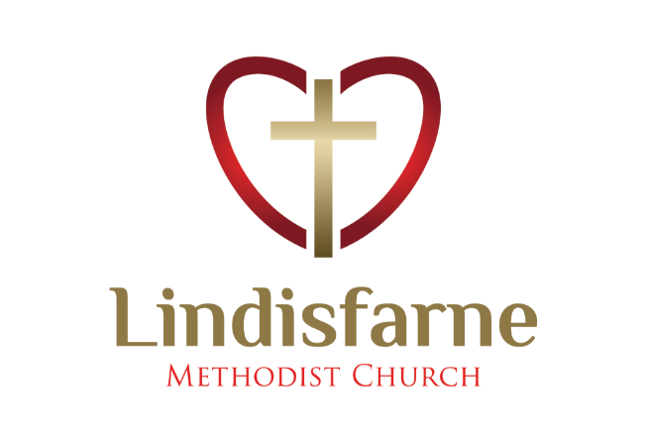
Lindisfarne Methodist Church, Worship and Community Centre.
22 Lindisfarne Street. Invercargill 9812 Phone 216-0281.
e-mail: office@lindisfarne.org.nz Website: www.lindisfarne.org.nz
Lindisfarne Methodist Church.

Sunday October 17th 2021.

10.00am: Lindisfarne Service led by Reverend Peter Taylor.
Service includes Congregational A.G.M.

10.00am Bluff Service led by Neil Salter

Prayer:
“The Son of Man came to give his life and to redeem many people”. Mark10;45.
Loving God, we thank you for the servant love of Jesus and for the people who through your power have extended that service to us and to others.
Help us daily to see ways to serve you in obedience.

Calendar
Sunday  October 17th | 10.00am  10.00am  6.00pm | Lindisfarne Service with Reverend Peter Taylor. Service includes Congregational AGM.  Bluff Service led by Neil Salter.  Private Booking.
Monday 18th | 5.30pm | Girl Guiding New Zealand
Tuesday 19th | 9.30am | Oranga Tamariki.
Wednesday 20th | 8.30am | Crestclean.
Thursday 21st | 8.30am  1.30pm  7.00pm | Crestclean  Sit and be Fit.  South City Choir meeting.
Friday 22nd | 8.30am | Crestclean.
Saturday 23rd | 8.00am  4.00pm | Tongan Church.  Private Booking.
Sunday  October 24th | 10.00am  1.00pm  1.00pm | Lindisfarne Service with Reverend Peter Taylor.  Tongan Service. TBA  Fijian Service. TBA

Church Van
For many years we have brought people to our Sunday service in our van. Unfortunately, we may have to reduce the number of times this can happen, because we do not have enough drivers.
Please think hard about whether you could help. Tell Peter or Noeline.
Farewell Les

We were saddened this last week by the death of Les Woodward. He was a very loyal member of our church family, especially at St Peters, where he used his secretarial and accounting skills over many years.
Les served for three years as a Parish Steward.
Always cheerful, he never complained about his disability resulting from having contracted polio as a child.
More recently he moved to Vickery Court and devoted his time to the care of his wife Jean who died just six months ago.

Covid Contact Tracing
During Covid Lockdown we are required to have a record either by cell phone app. or by signing one of the registers at the entrances, of any unscheduled visits ie not regular meetings, we make to Lindisfarne.
This is optional on Sunday mornings as Margaret records attendances.
Group leaders should leave in the office lists of attenders at meetings.

Cheese Rolls
There are a few cheese rolls available for sale -mostly brown- at the regular price of $8 a dozen or $30 for four dozen.
Please see Margaret or Noeline after today’s service.
Note: If you are paying for purchases already made, please put your money in a named envelope and give it to Margaret.
There are envelopes on the foyer table.

Sit and be Fit
Do you need a little easy exercise (seated)?
Come to the Sit and be Fit class at 1.30pm on Thursdays.
ROSTER FOR SUNDAY DUTIES.
Sunday |  | October 17th | October 24th |  | October 31st | November 7th
DOOR |  | Evelyn and Neil Cruickshank | Muriel and Cam McCulloch |  | Raewyn Birss  Dot Anderson | Bryon and Dorothy King
VAN |  | Sharon Taylor |  |  | Bryon King
MORNING TEA |  | No morning tea in Delta Level 2  Check the blue roster for upcoming duties
FLOWERS |  | Dorothy King | Mags Kelly |  | Dot Anderson | Betty Snell
NOTICES | Carolyn McDonald |  | Evelyn Cruickshank | TBA |  | TBA
CRECHE |  | School Holidays | Labour Weekend | Betty Snell |  | Carol McKenzie
KIDS KLUB |  | School Holidays | Labour Weekend | Carol McKenzie |  | Heather Kelly

CENTRE DUTIES
WEEK OF | LAWNS | SECURITY
October 18th – October 24th | Ian Findlay | Eddie Bremer
October 25^{th-} -October 31st | Nicol Macfarlane | Cam McCulloch
November 1st – November 7th | Lester Dean | Margaret Brass
November 8th – November 14th | Runi Safole | Hartley Hare

Some Invercargill Parish Key Personnel

Presbyter & Parish Council Chairman Reverend Peter Taylor 216 0281
Parish Council Secretary Carolyn Weston
Parish Stewards Sarah Jenkin, Evelyn Cruickshank, Carolyn McDonald
Treasurer David Little
Parish Council Congregational Representatives
Margaret Brass, Mags Kelly, Darren Weston
Bookings Phone Office 216 0281
Prayer Chain Co-ordinator Mags Kelly
Bulletin Editors Peter Lankshear, Margaret Brass
Committee Convenors
Pastoral/Outreach – Noeline Collie (Pastoral Care Team – Betty Snell)
Finance/Property – Cam McCulloch (Health & Safety – Darren Weston)
Worship/Education – Neil Cruickshank

