Bulletin
The Invercargill Parish of the Methodist Church of New Zealand.
Te Hahi Weteriana o Aotearoa.
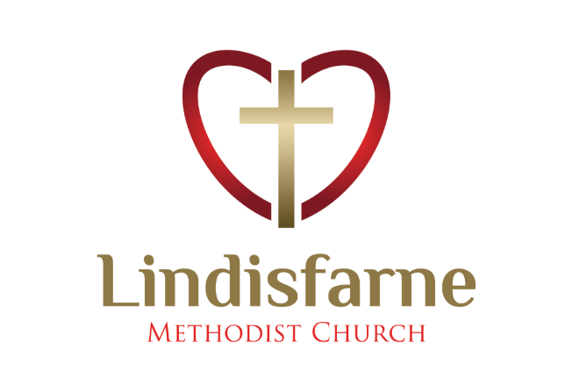
Lindisfarne Methodist Church, Worship and Community Centre.
22 Lindisfarne Street. Invercargill 9812 Phone 216-0281.
e-mail: office@lindisfarne.org.nz Website: www.lindisfarne.org.nz
Lindisfarne Methodist Church.

Sunday October 3rd 2021.

10.00am: Lindisfarne Service led by Reverend Peter Taylor

Prayer: Whoever does not receive the Kingdom of God like a child will never enter it Mark10:15.
Thank you, Lord, that your way is not complicated, your truth is not complex, and that your power enables us to be your effective servants.
May we have that childlike faith.

Calendar
Sunday  October 3rd | 10.00am | Lindisfarne Service with Reverend Peter Taylor.
Monday 4th | 5.00pm | Set up for Tuesday.
Tuesday 5th | 6.00pm  6.30pm  7.45pm | Private Booking  Parish Council Meeting.  Ladies Evening Group. See notice below.
Wednesday 6th | 1.30pm | Cheese Roll Making
Thursday 7th | 8.30am  1.30pm | Plunket.  Sit and be Fit.
Friday 8th | 3.00pm | Set up for Saturday.
Saturday 9th | 3.00pm  5.00pm | Private Booking for M/P Room.  Private Booking for Lounge.
Sunday  October 10th | 10.00am  1.00pm  6.00pm | Lindisfarne Service with Reverend Peter Taylor.  Fijian Service.  Private Booking

Legs
Legs will meet at 7.45pm in the lounge on Tuesday 5th October.
Deirdre and Carol will be the Hostesses.
Duties Roster
Please collect your copy of the new (blue) roster. At present the only duties needed are – Security, Lawns and perhaps Flowers and Van.

Brown Bags
There has been a steady demand for Brown Bags but our stocks of food are holding out well. It would be good to have more empty egg cartons, especially the half dozen size.

Covid Contact Tracing
During Covid Lockdown we are required to have a record, either by cell phone app. or by signing one of the registers at the entrances, of any unscheduled visits we make to Lindisfarne.
This is optional on Sunday mornings as Margaret records attendances.
Group leaders should leave, in the office, lists of attendees at meetings.

An Invitation
All women are invited to a Celebration Meeting with Guest Speaker, Commissioner Julie Campbell
(President of Salvation Army Women’s Ministries in NZ)
Come to Salvation Army 30 Victoria Ave from 10.00am on Monday 18 October (Morning Tea and Lunch provided – RSVP by 11 Oct)

Office Hours Next Week
Monday, Wednesday, and Friday – about 10.00 am to about 1.30 pm

Church Van
For many years we have brought people to our Sunday service in our van. Unfortunately, we may have to reduce the number of times this can happen, because we do not have enough drivers. Please think hard about whether you could help. Tell Peter or Noeline.
Cheese rolls
After several postponements we are planning to make the cheese rolls that were ordered in August. If you can help from 1.30 pm next Wednesday afternoon 6th October please tell Noeline or Margaret. (You must be gloved, masked, and aproned). NO NEW ORDERS are being accepted.
Planned for later this year (Covid permitting)

A pleasant afternoon out early in November.

Garage sale Saturday 13 November.
ROSTER FOR SUNDAY DUTIES.
Sunday | October 3rd |  | October 10th | October 17th |  | October 24th
DOOR | Tony Weston  Nicol Macfarlane |  | Ita and Runi Safole | Evelyn and Neil Cruickshank |  | Muriel and Cam McCulloch
VAN | Daphne Salter |  |  | Sharon Taylor |  | Ian Findlay
MORNING TEA | No Morning Tea |  | No Morning Tea | Sarah and Jo???? |  | Beverly S and Christine?????
FLOWERS | Ita Safole |  | Raewyn Birss | Dorothy King |  | Mags Kelly
NOTICES | Sarah Jenkin | Evelyn Cruickshank |  | Carolyn McDonald |  | Evelyn Cruickshank
CRECHE | School Holidays |  | School Holidays | School Holidays |  | Labour Weekend
KIDS KLUB | School Holidays |  | School Holidays | School Holidays | Labour Weekend

CENTRE DUTIES
WEEK OF | LAWNS | SECURITY
October 4th – October 10th | Findlay Collie | Hartley Hare
October 11th- October 17th | Bryon King | Darren Weston
October 18th – October 24th | Ian Findlay | Margaret Brass
October 25^{th-} -November 1st | Nicol Macfarlane | Cam McCulloch

Some Invercargill Parish Key Personnel

Presbyter & Parish Council Chairman Reverend Peter Taylor 216 0281
Parish Council Secretary Carolyn Weston
Parish Stewards Sarah Jenkin, Evelyn Cruickshank, Carolyn McDonald
Treasurer David Little
Parish Council Congregational Representatives
Margaret Brass, Mags Kelly, Darren Weston
Bookings Phone Office 216 0281
Prayer Chain Co-ordinator Mags Kelly
Bulletin Editors Peter Lankshear, Margaret Brass
Committee Convenors
Pastoral/Outreach – Noeline Collie (Pastoral Care Team – Betty Snell)
Finance/Property – Cam McCulloch (Health & Safety – Darren Weston)
Worship/Education – Neil Cruickshank

